Table of Contents

Zero HVDC power: UDC step down 2

Zero HVDC power: UDC step down 3

Zero HVDC power: UDC step up 4

Zero HVDC power: UDC step up 5

Zero HVDC power: P step down 6

Zero HVDC power: P step down 7

Zero HVDC power: P step up 8

Zero HVDC power: P step up 9

Zero HVDC power: Q step up 10

Zero HVDC power: Q step up 11

Zero HVDC power: Q step down 12

Zero HVDC power: Q step down 13

Zero HVDC power: 3pSC fault at the grid's PCC 14

Zero HVDC power: 3pSC fault at the grid's PCC 15

1GW HVDC power: UDC step down 16

1GW HVDC power: UDC step down 17

1GW HVDC power: UDC step up 18

1GW HVDC power: UDC step up 19

1GW HVDC power: P step down 20

1GW HVDC power: P step down 21

1GW HVDC power: P step up 22

1GW HVDC power: P step up 23

1GW HVDC power: Q step up 24

1GW HVDC power: Q step up 25

1GW HVDC power: Q step down 26

1GW HVDC power: Q step down 27

1GW HVDC power: 3pSC fault at the grid's PCC 28

1GW HVDC power: 3pSC fault at the grid's PCC 29

# Zero HVDC power: UDC step down

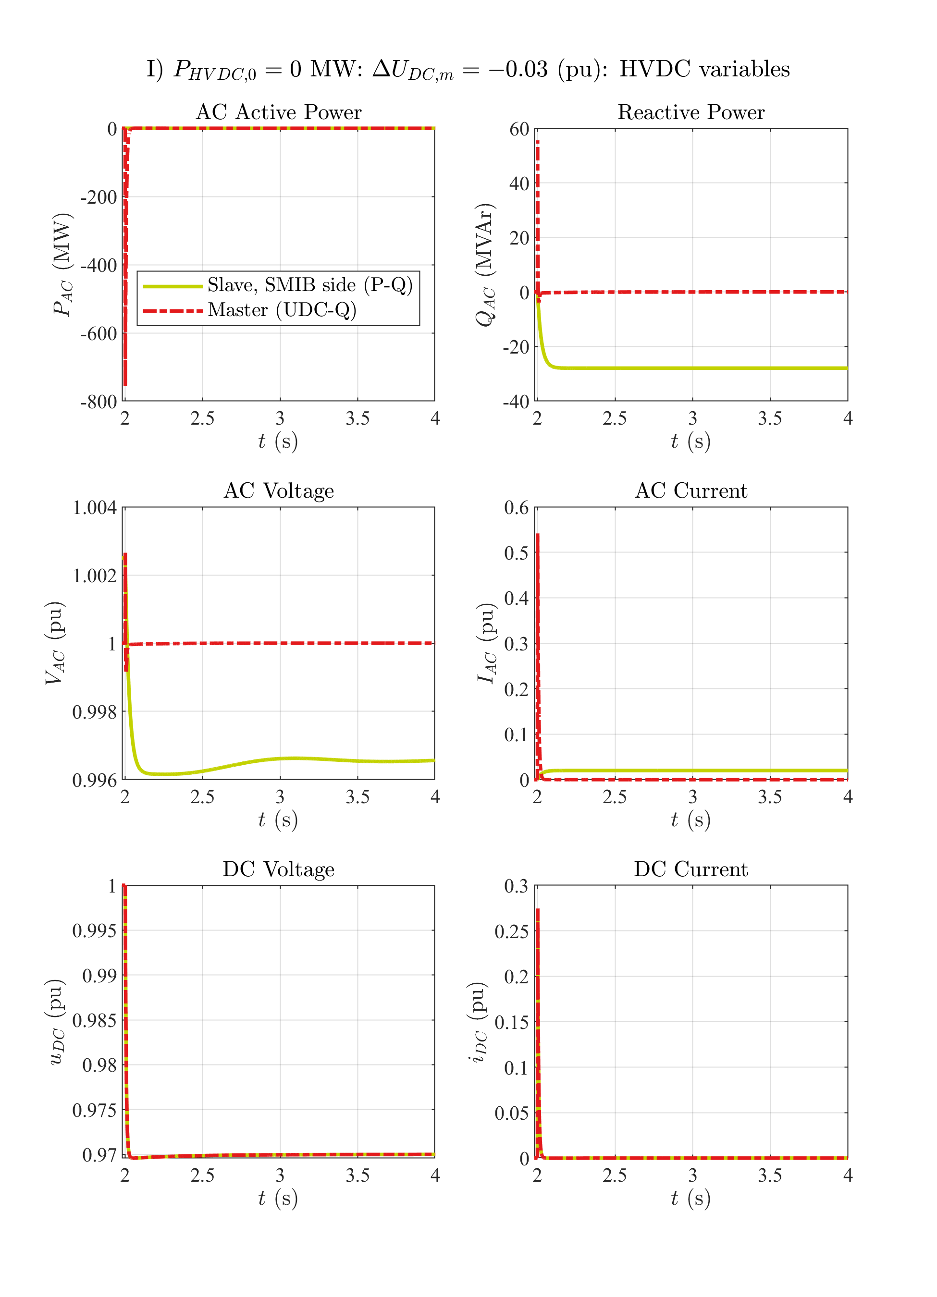

# Zero HVDC power: UDC step down

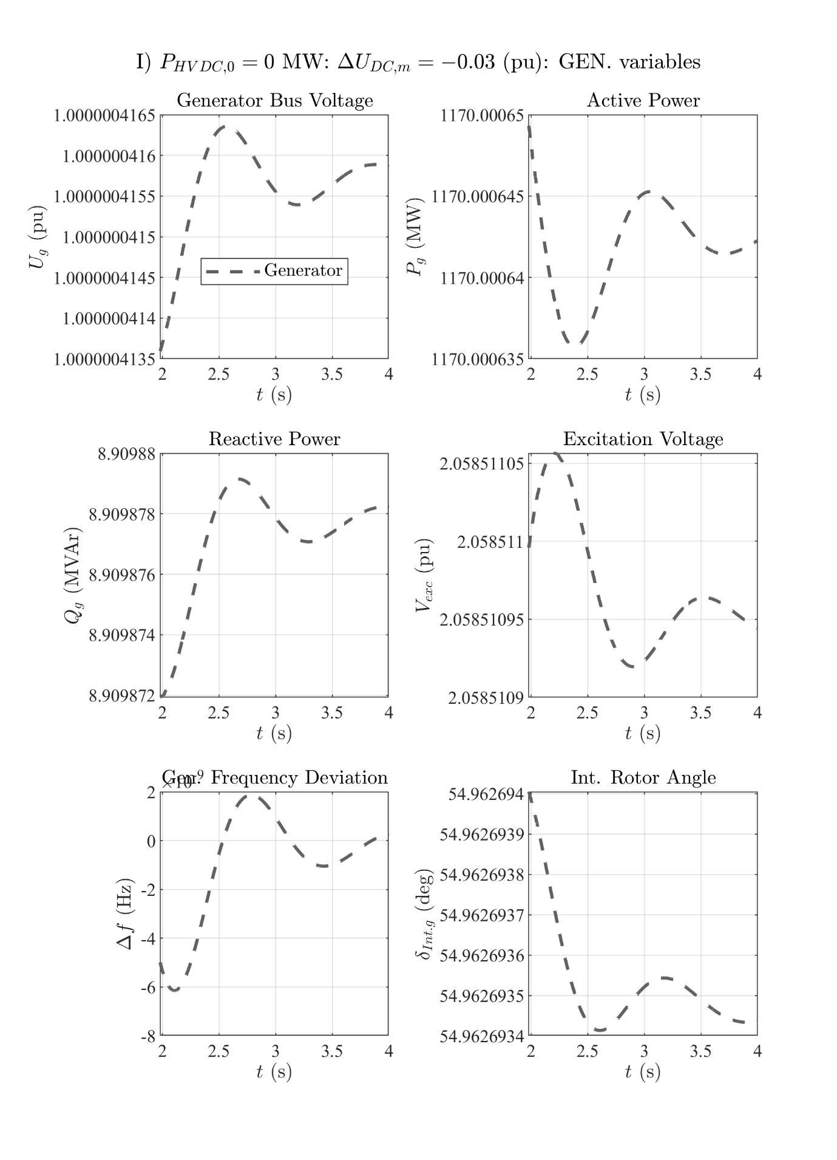

# Zero HVDC power: UDC step up

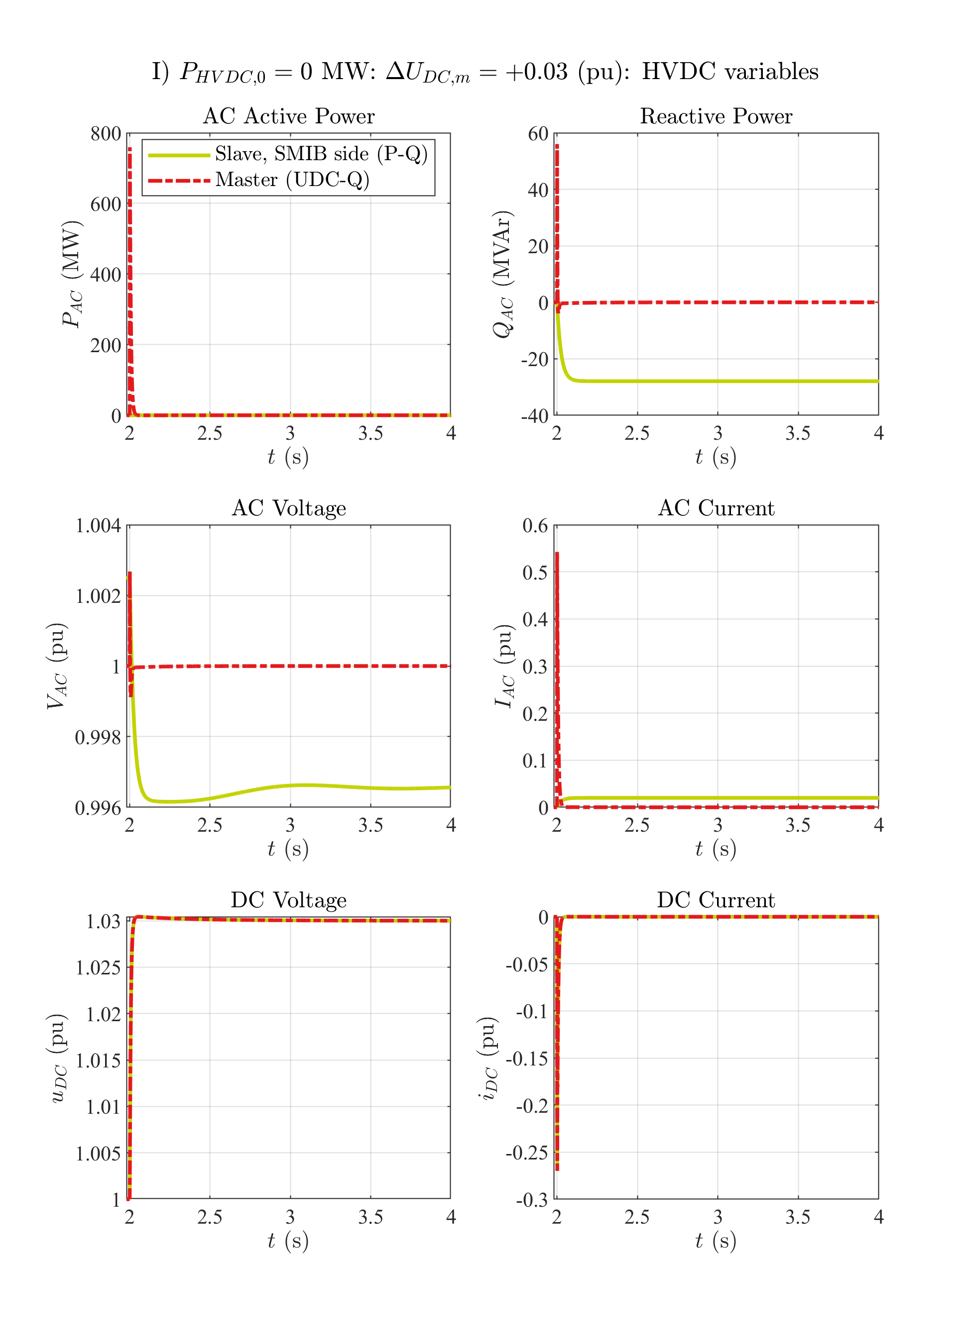

# Zero HVDC power: UDC step up

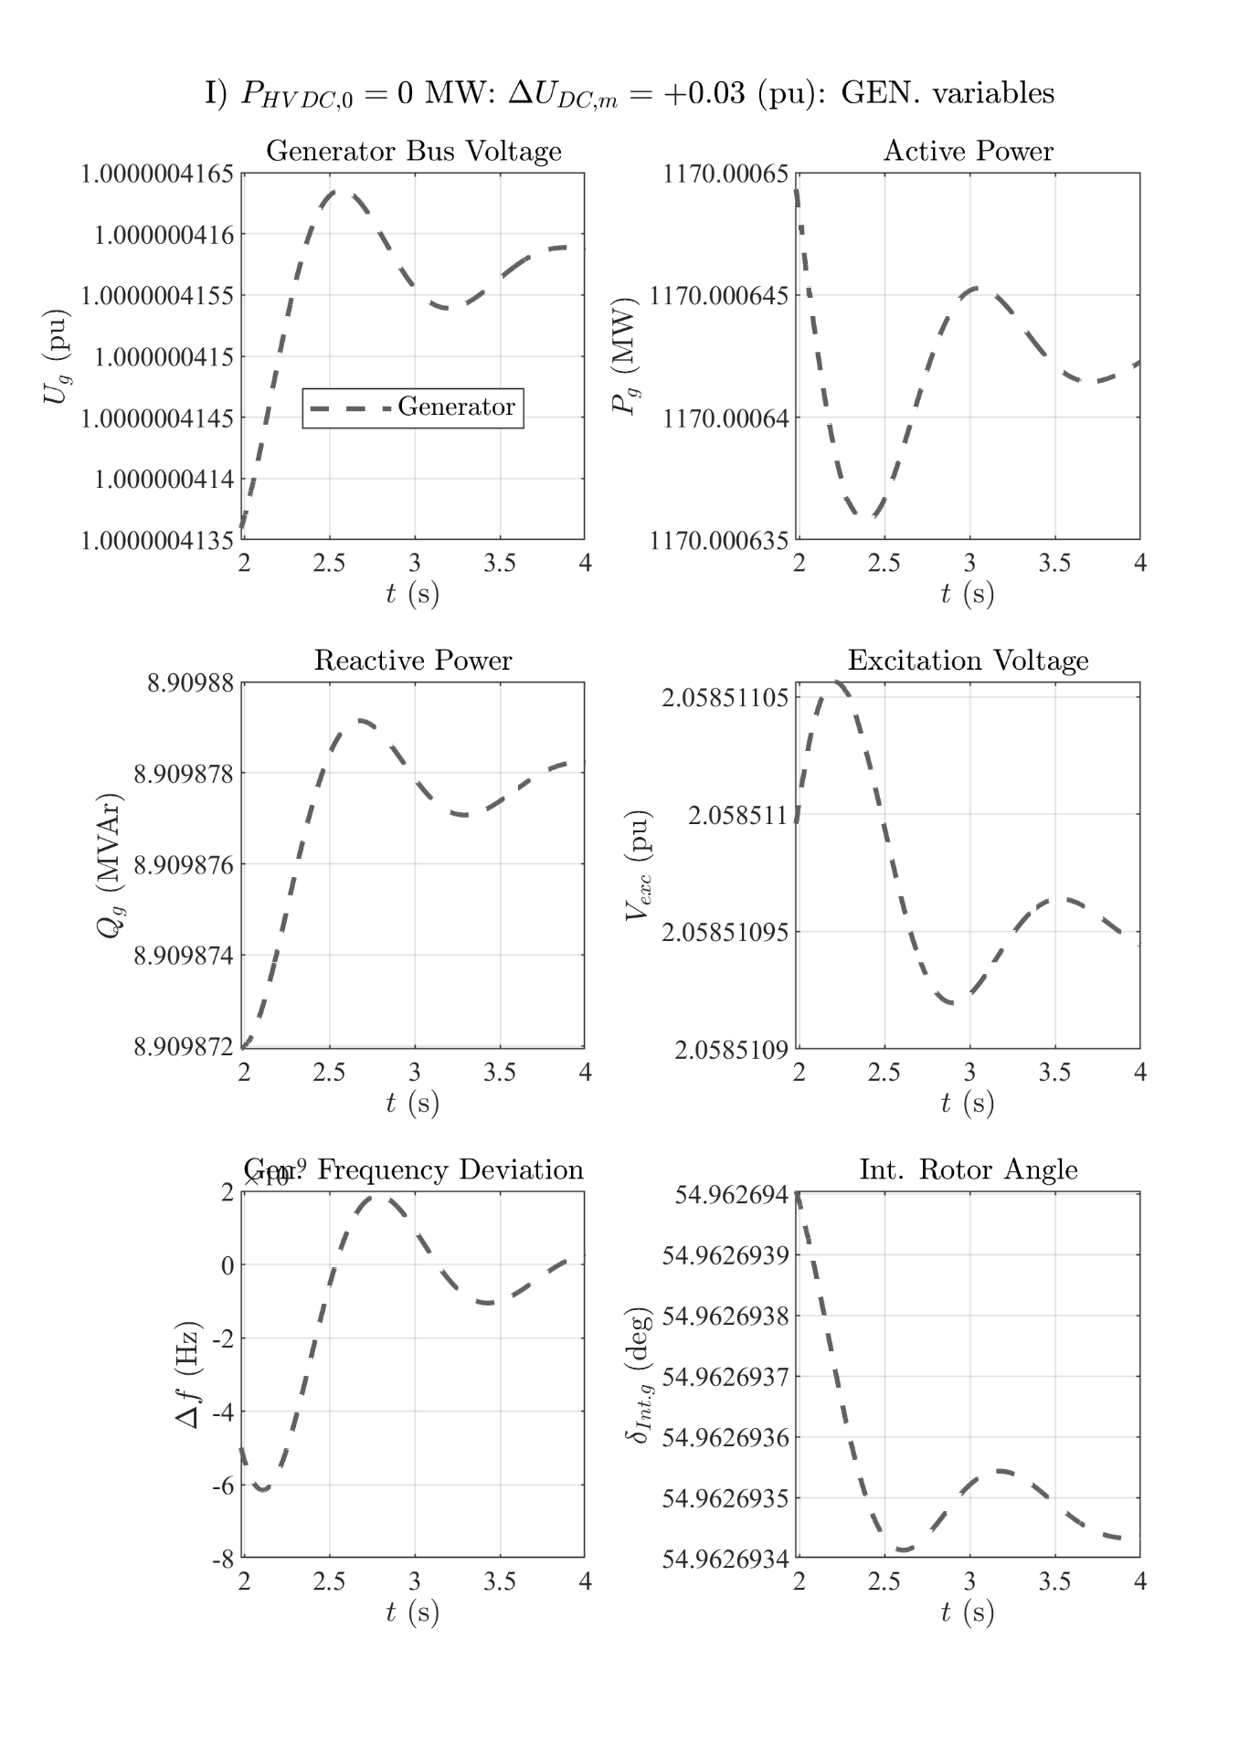

# Zero HVDC power: P step down

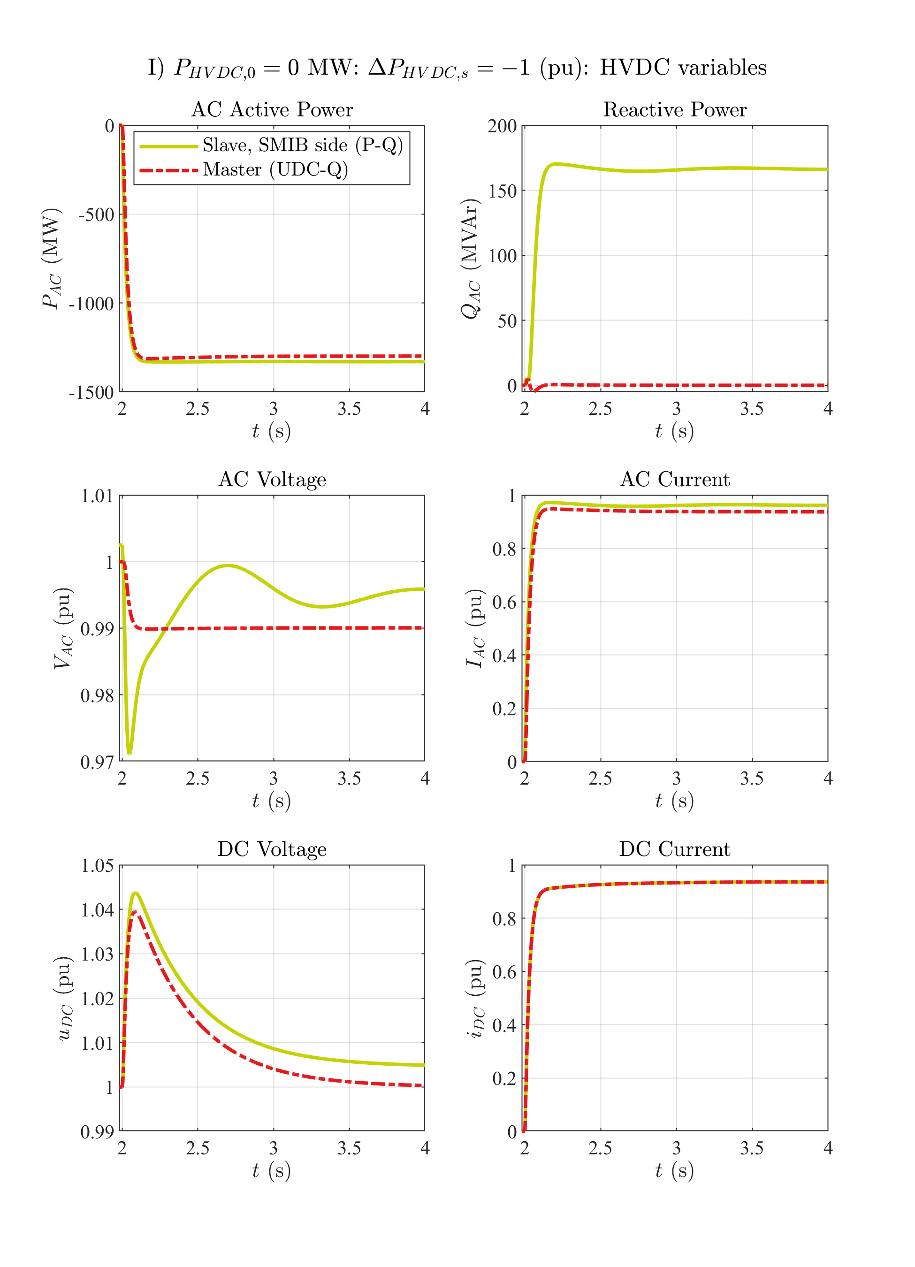

# Zero HVDC power: P step down

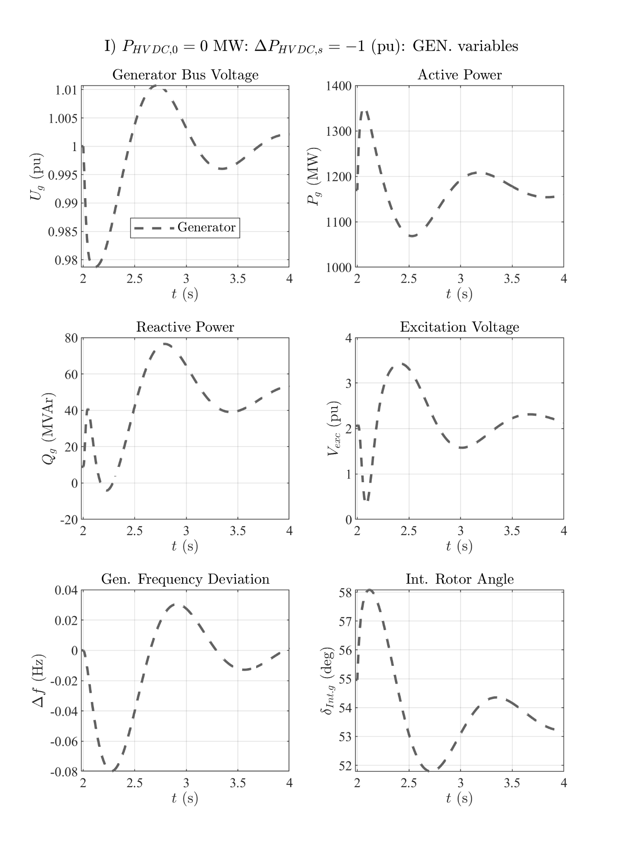

# Zero HVDC power: P step up

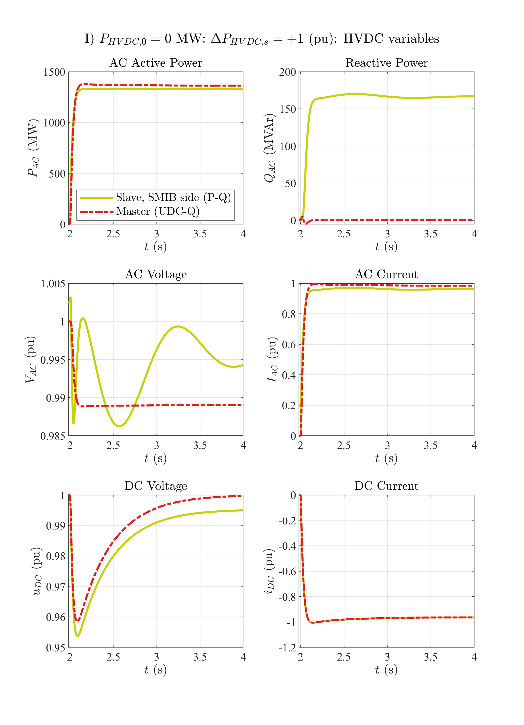

# Zero HVDC power: P step up

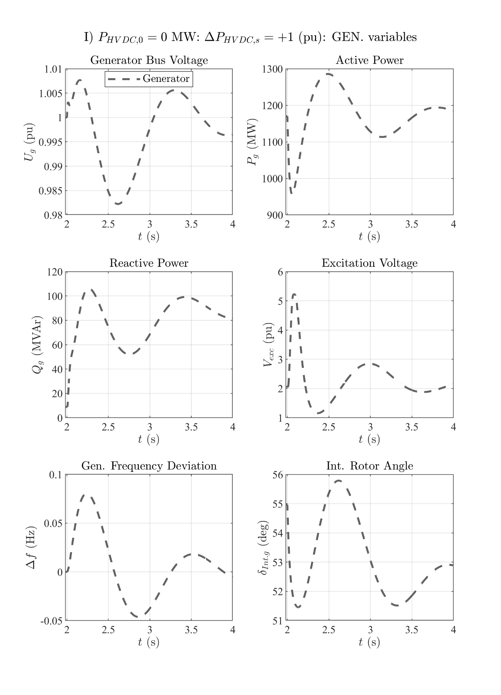

# Zero HVDC power: Q step up

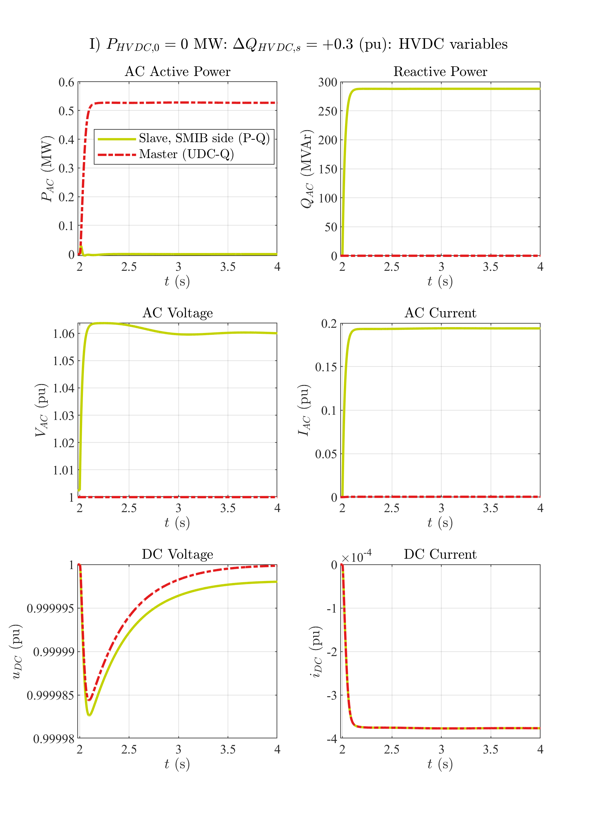

# Zero HVDC power: Q step up

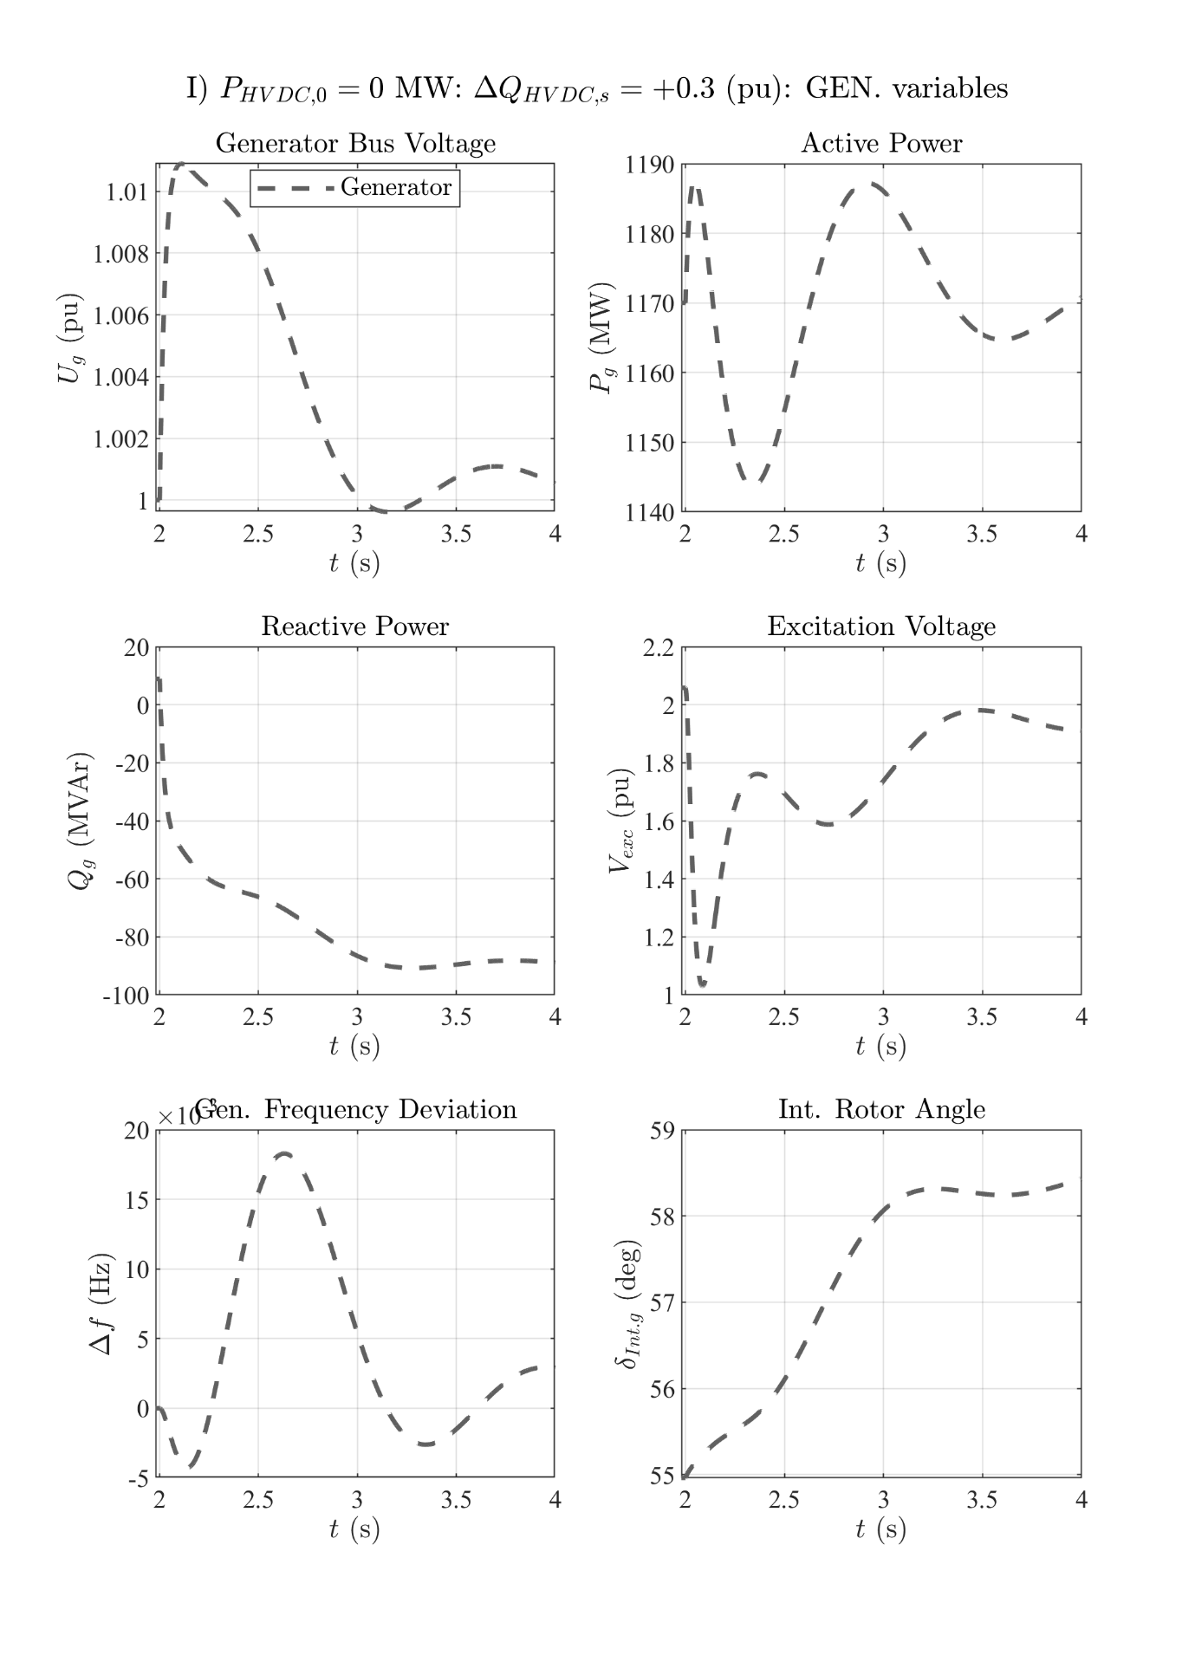

# Zero HVDC power: Q step down

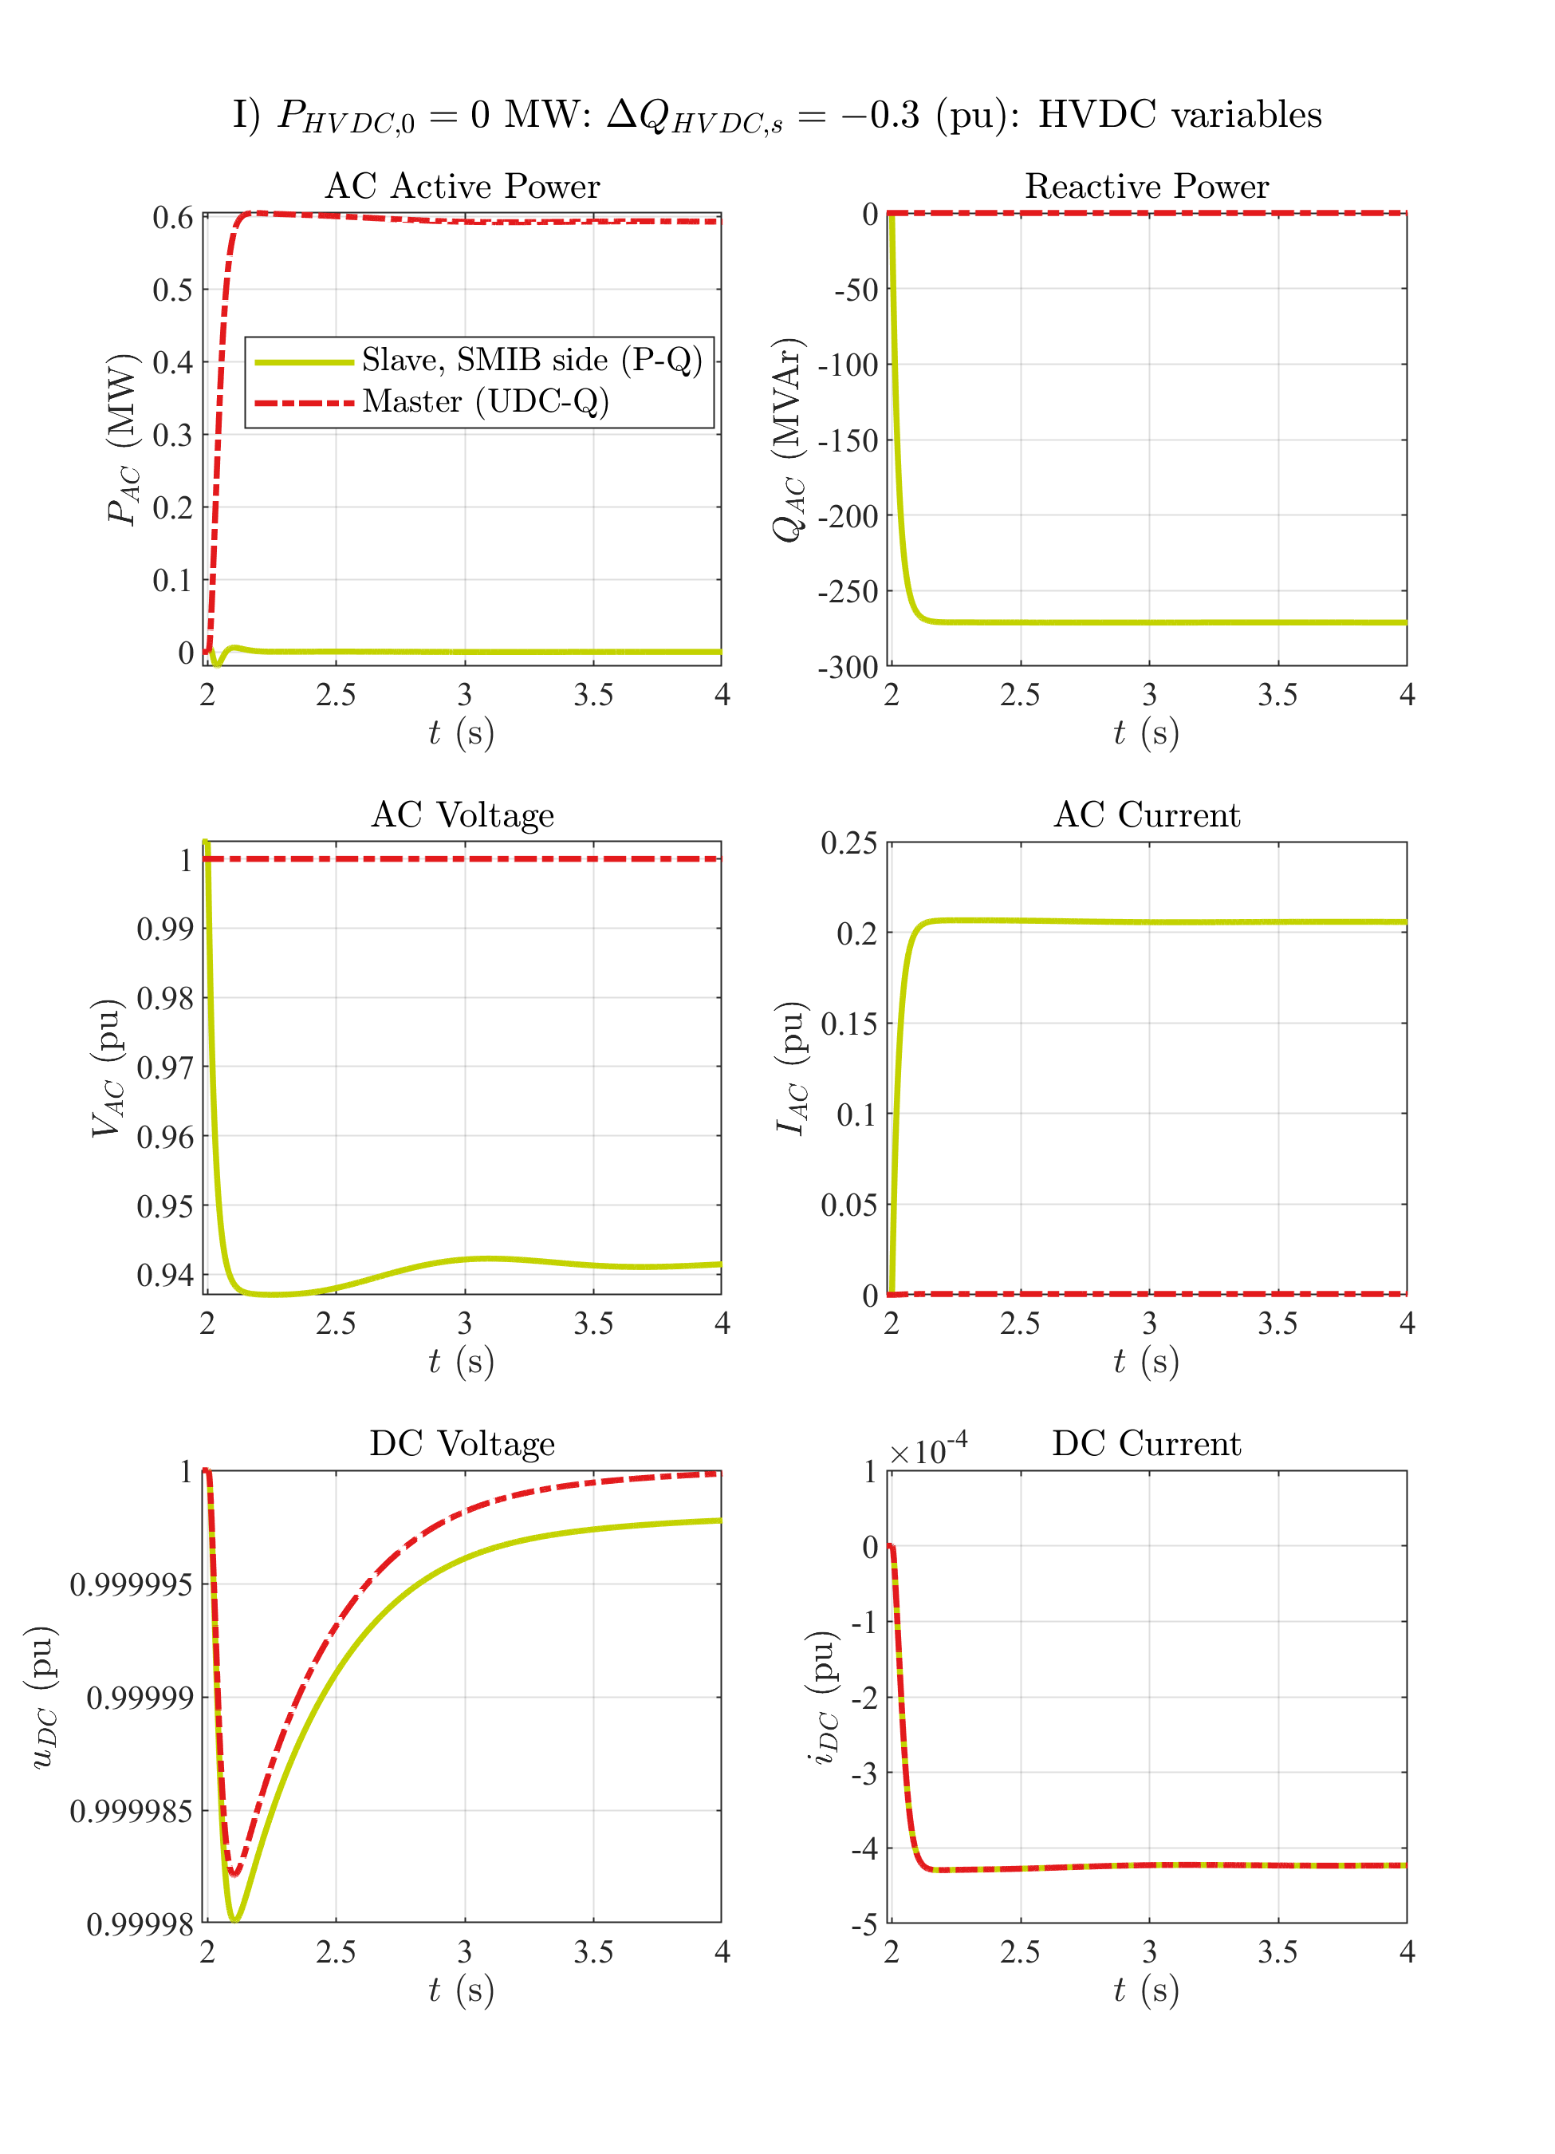

# Zero HVDC power: Q step down

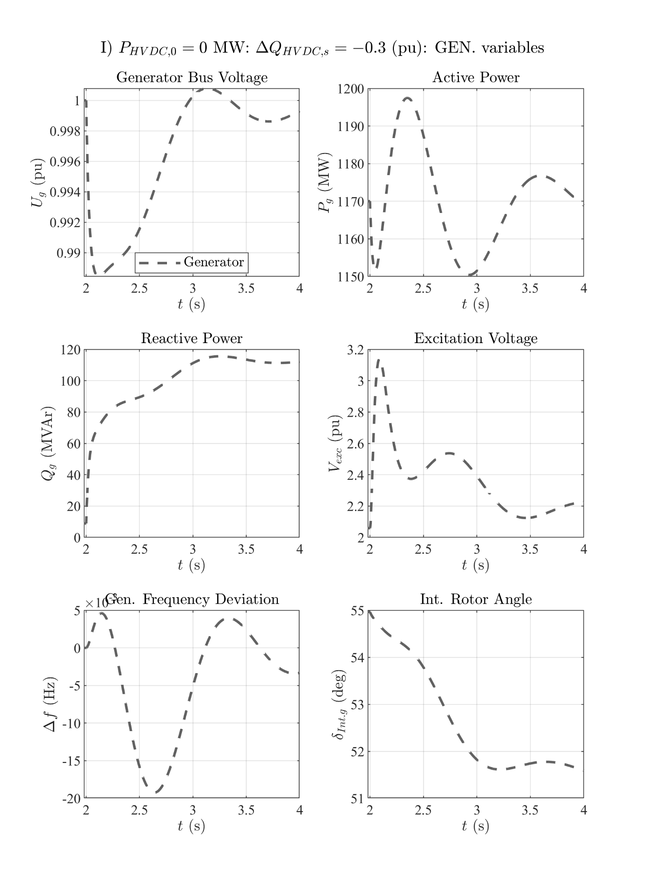

# Zero HVDC power: 3pSC fault at the grid's PCC

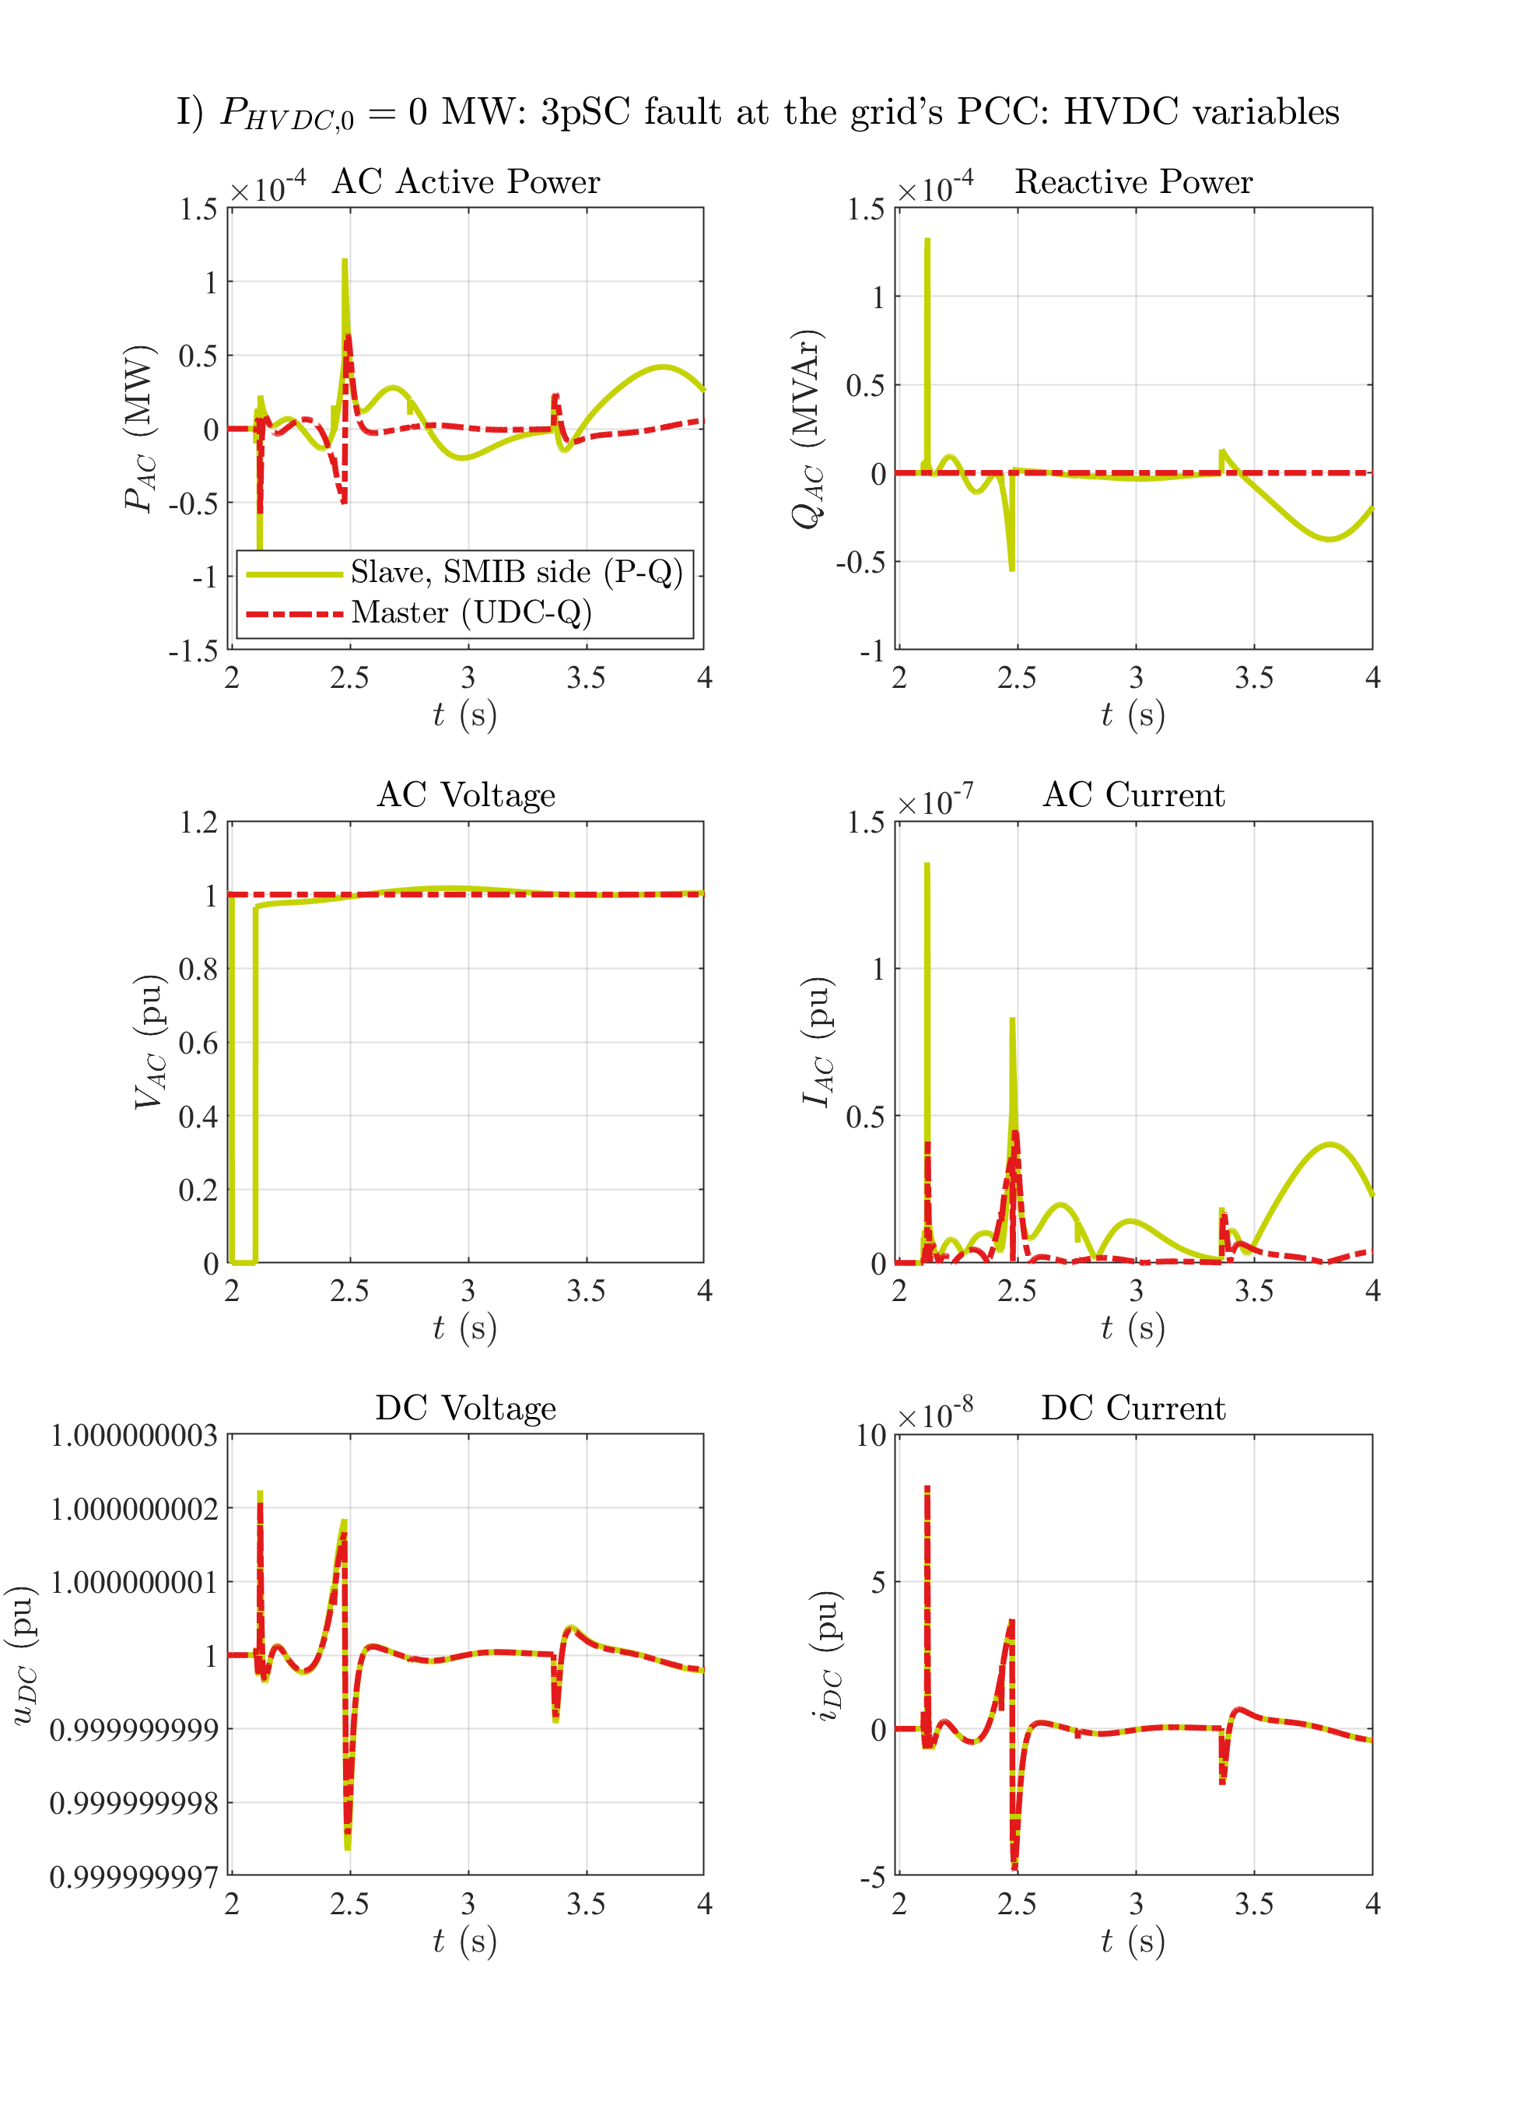

# Zero HVDC power: 3pSC fault at the grid's PCC

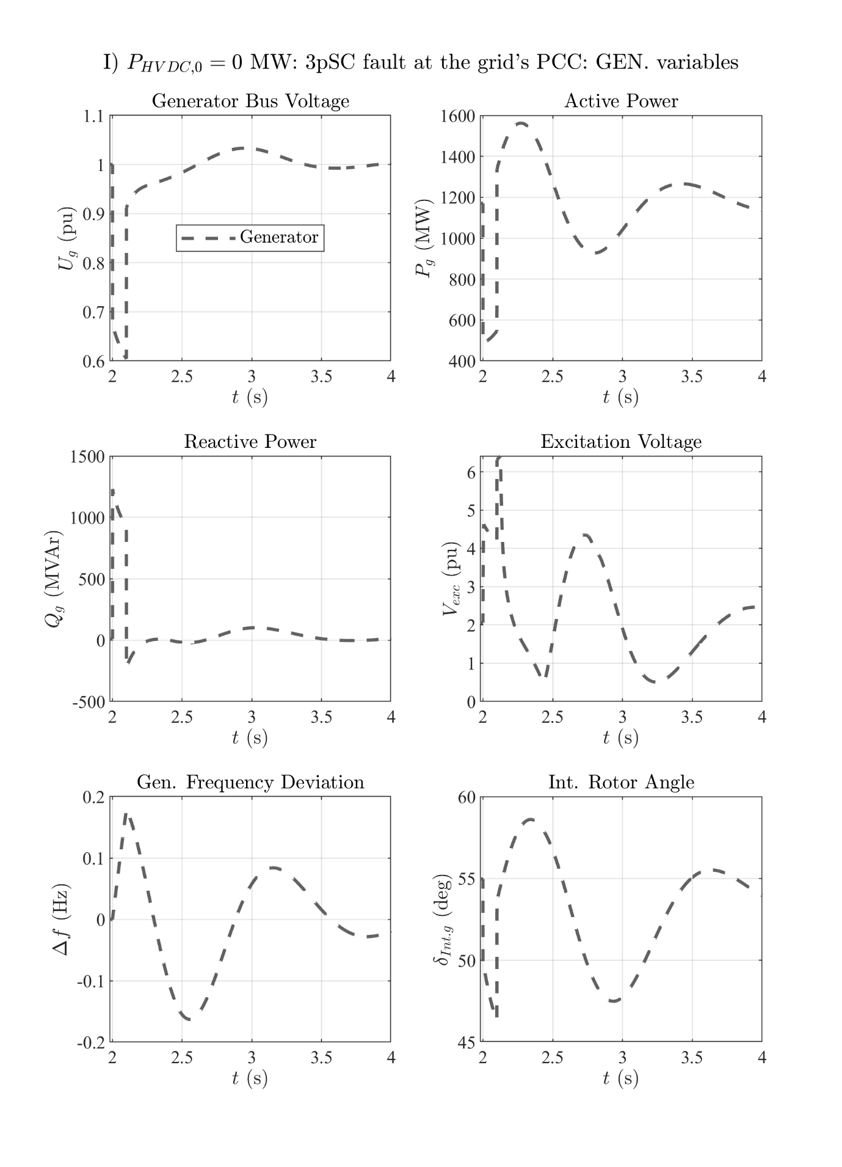

# 1GW HVDC power: UDC step down

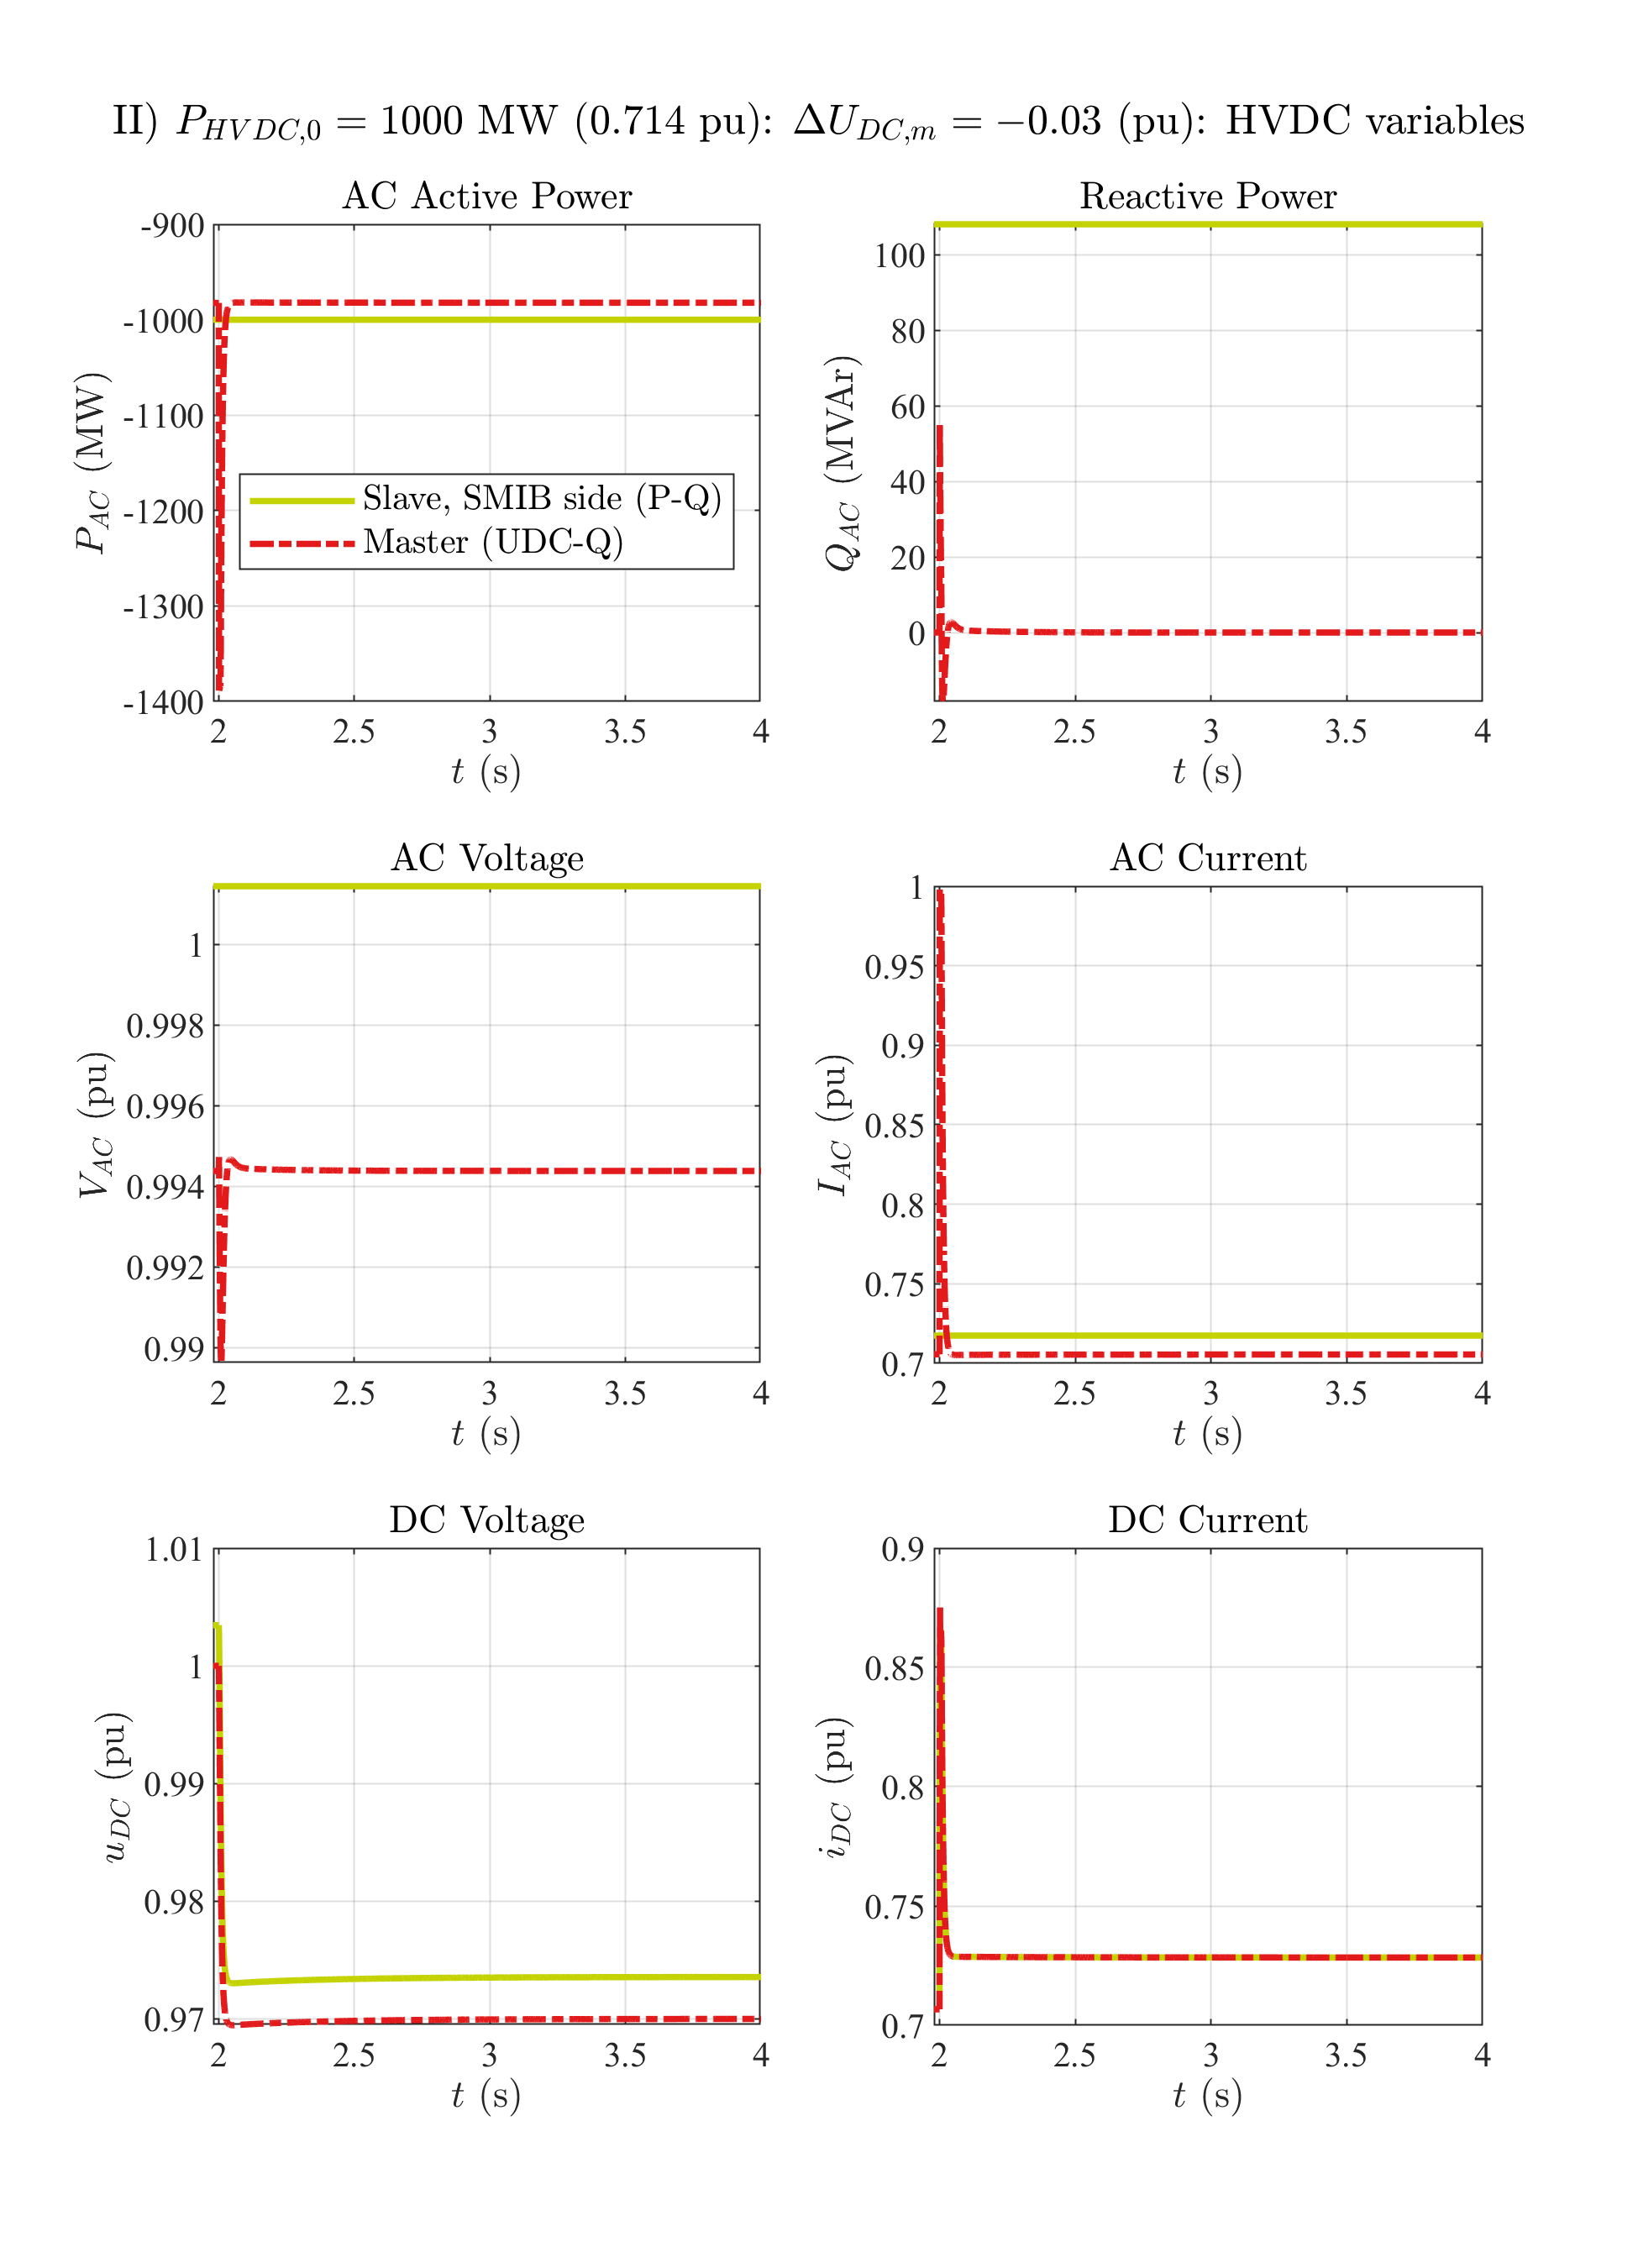

# 1GW HVDC power: UDC step down

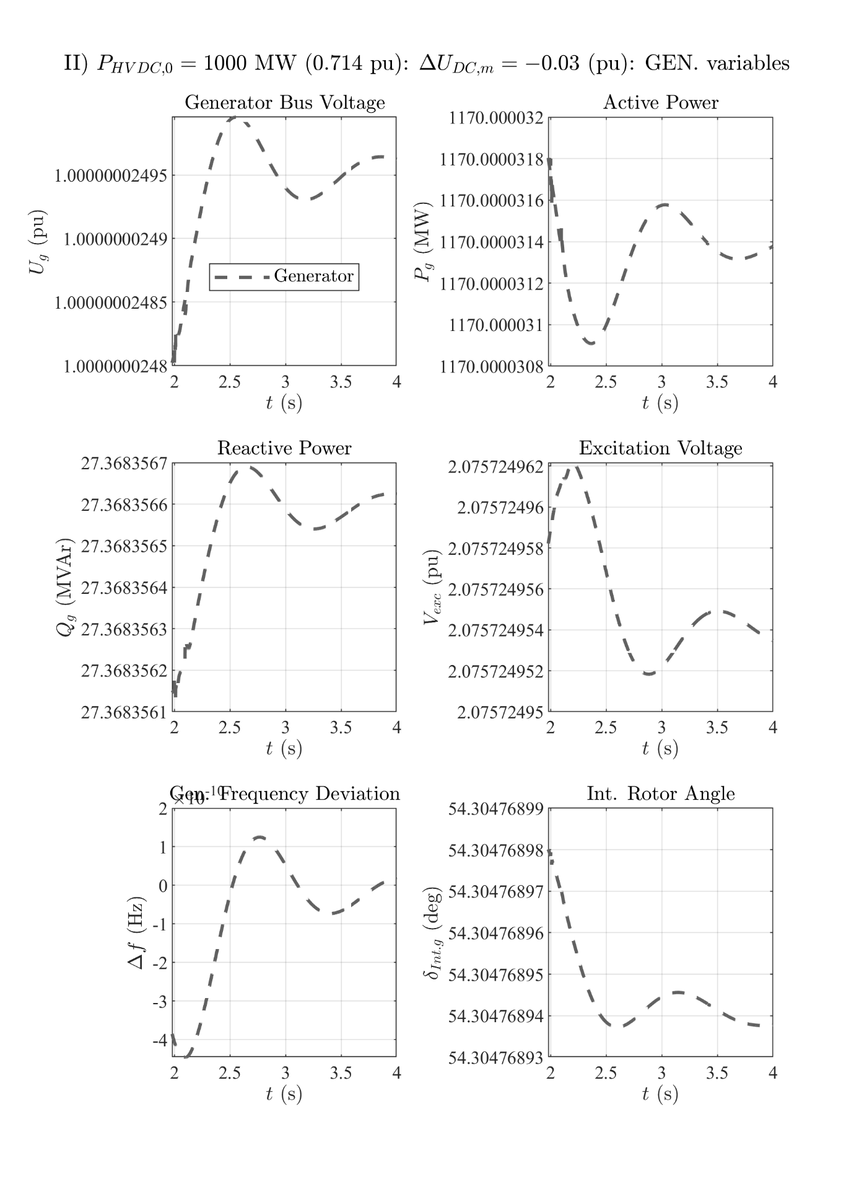

# 1GW HVDC power: UDC step up

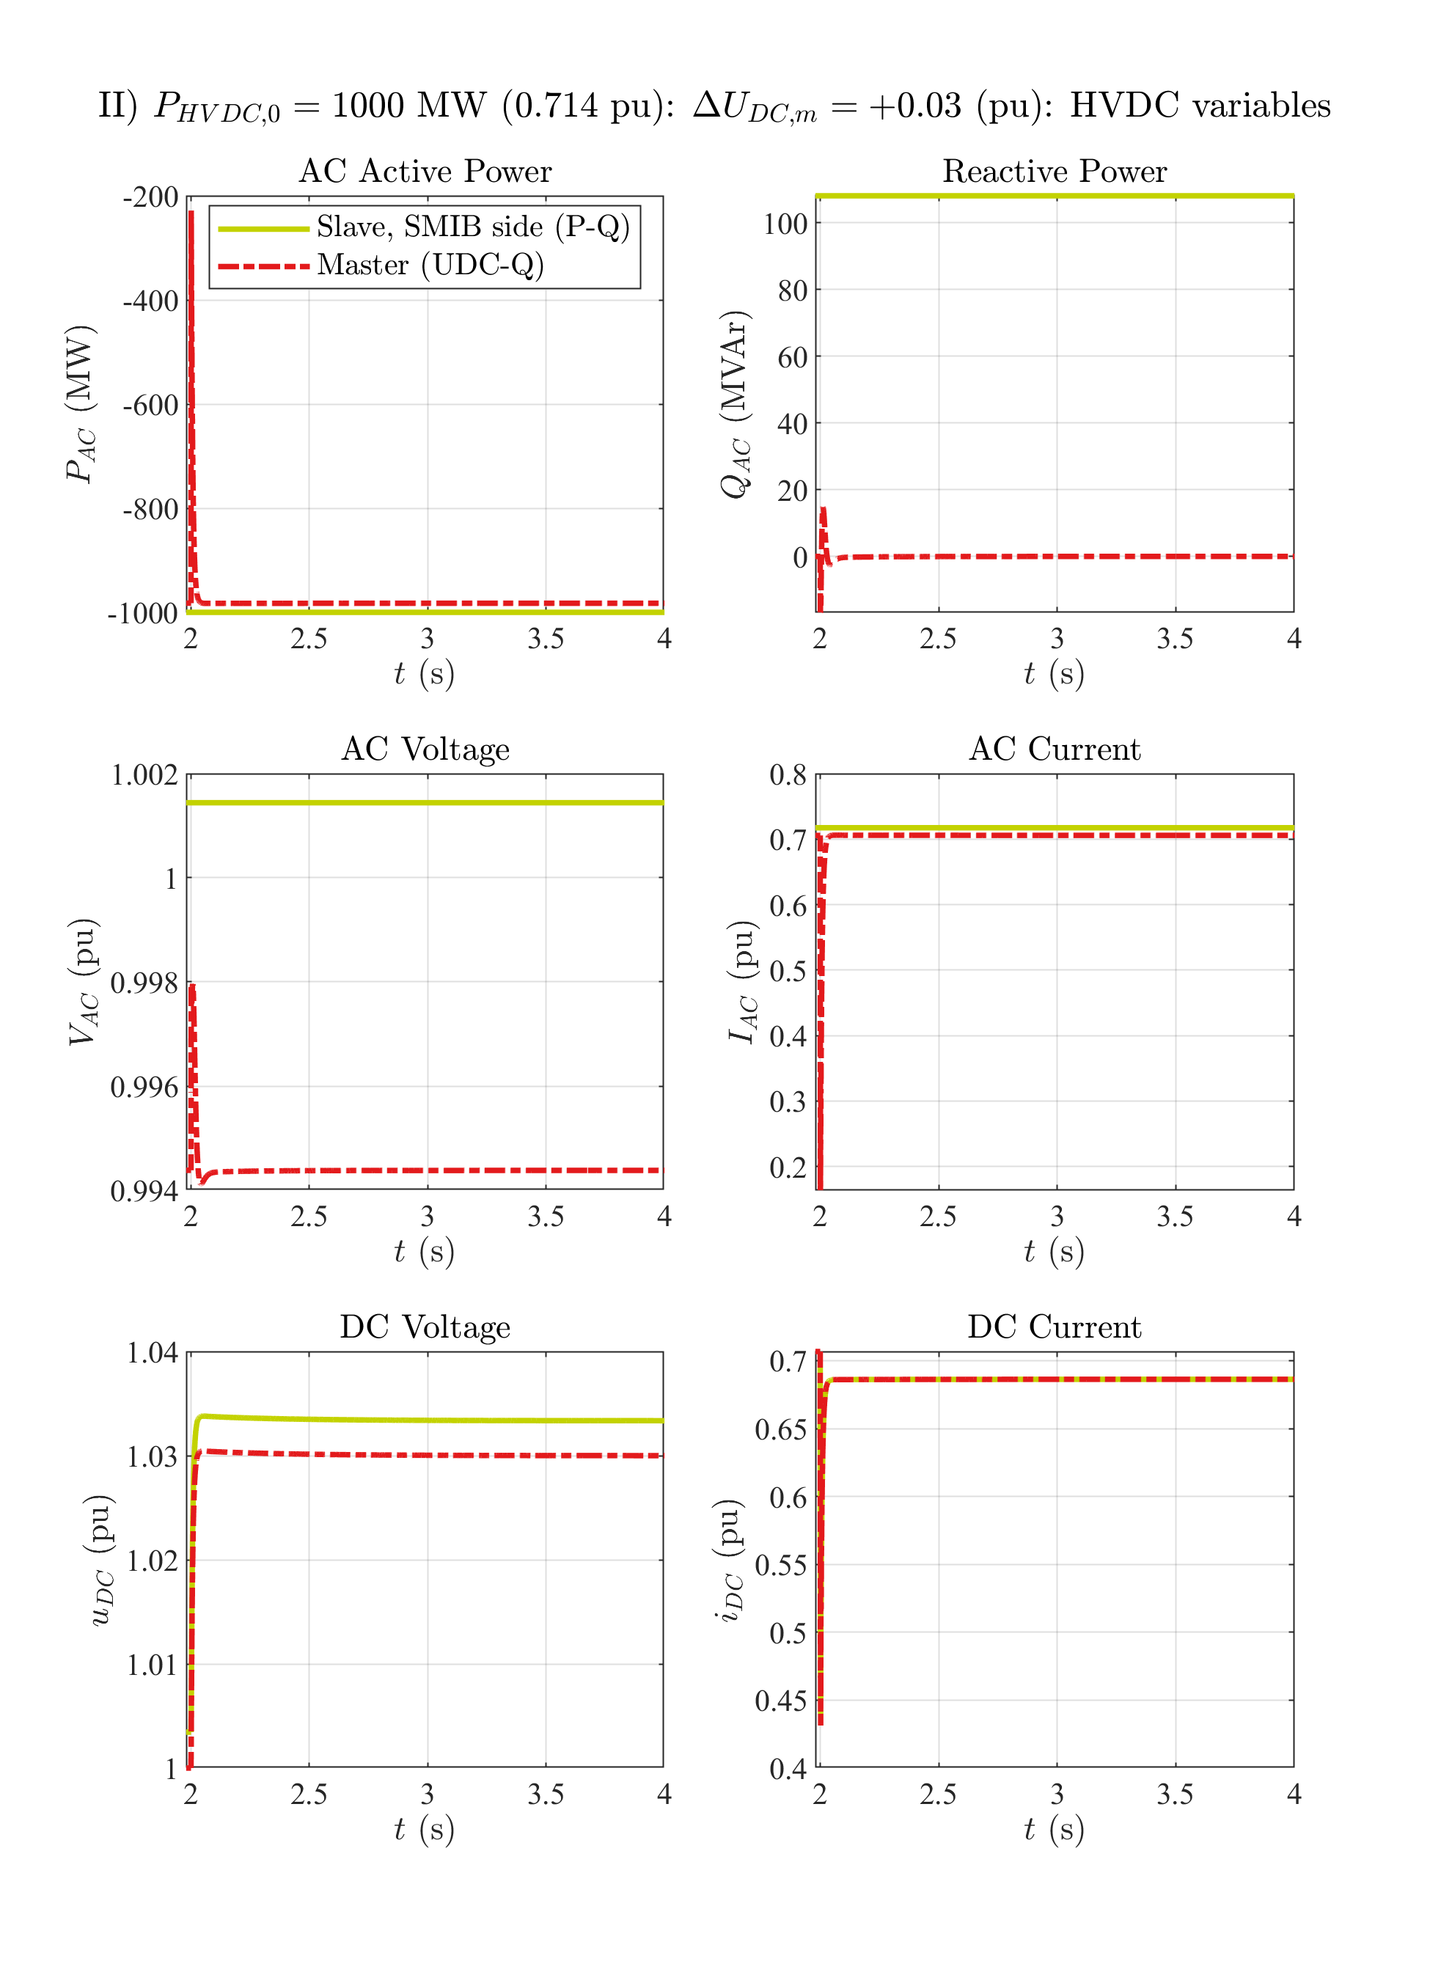

# 1GW HVDC power: UDC step up

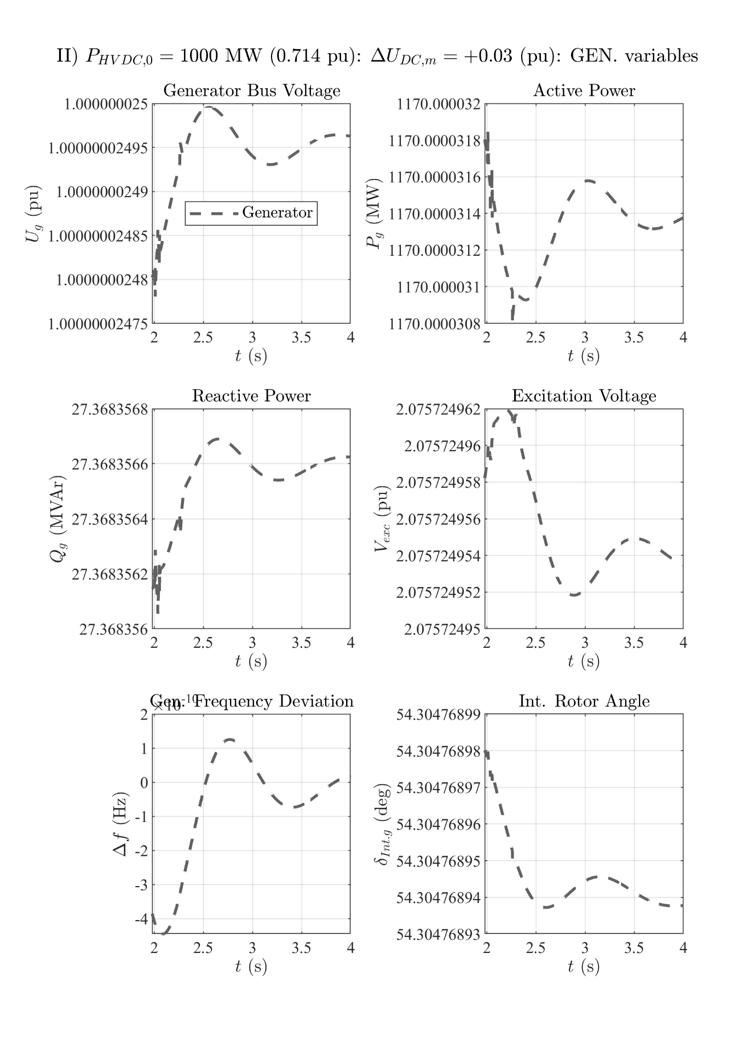

# 1GW HVDC power: P step down

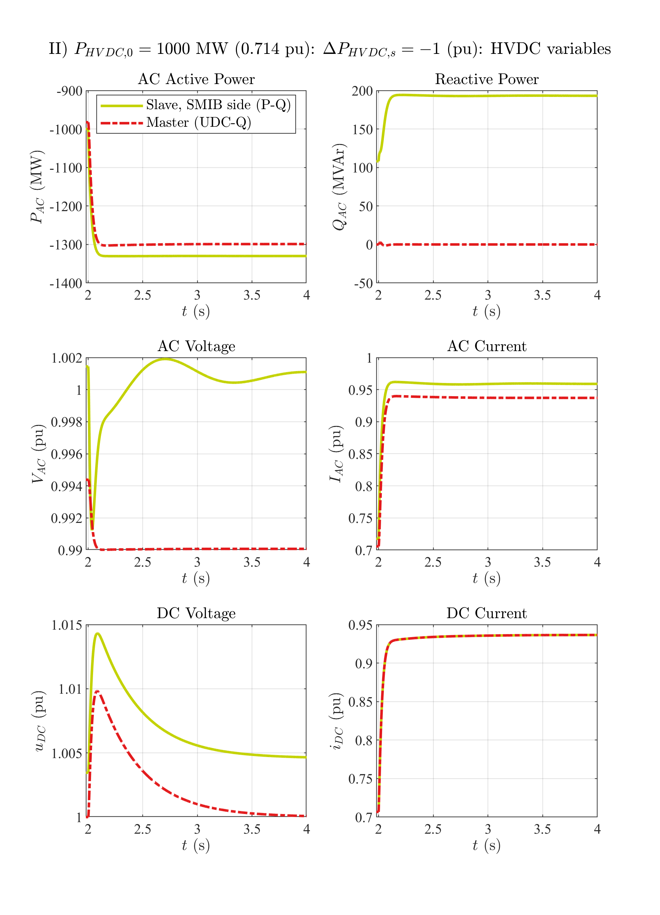

# 1GW HVDC power: P step down

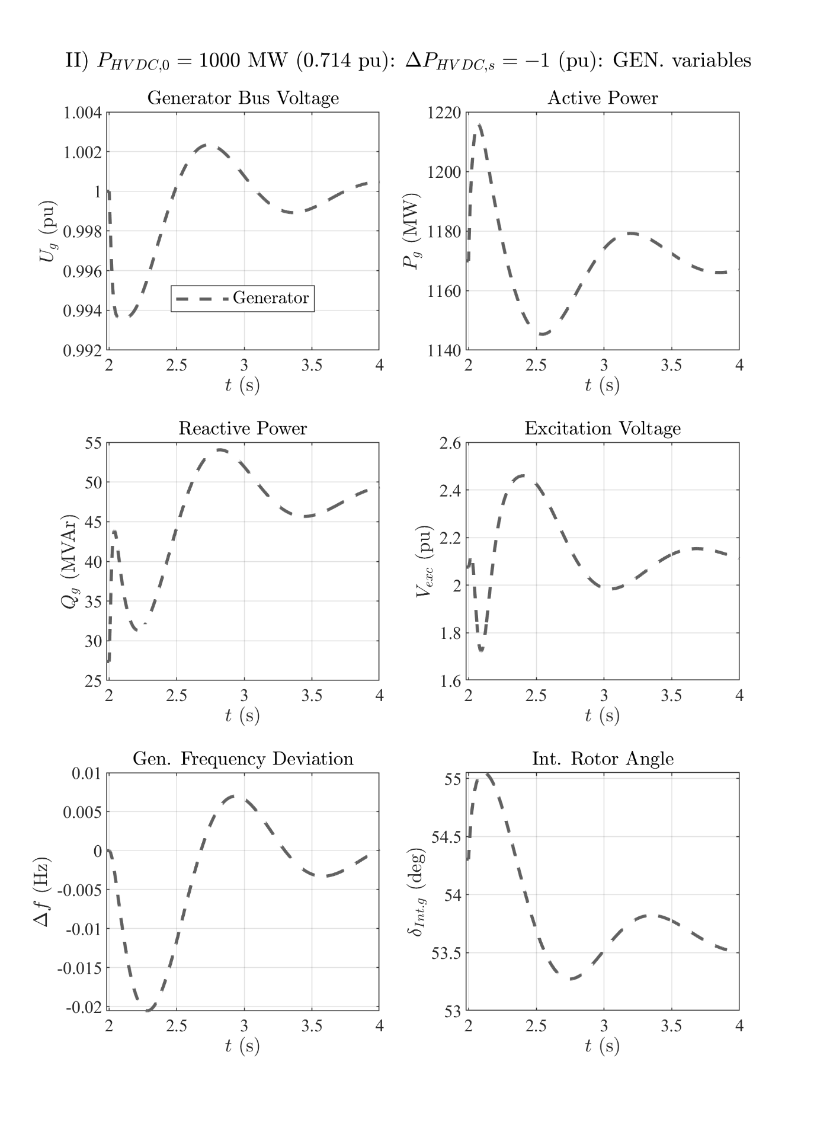

# 1GW HVDC power: P step up

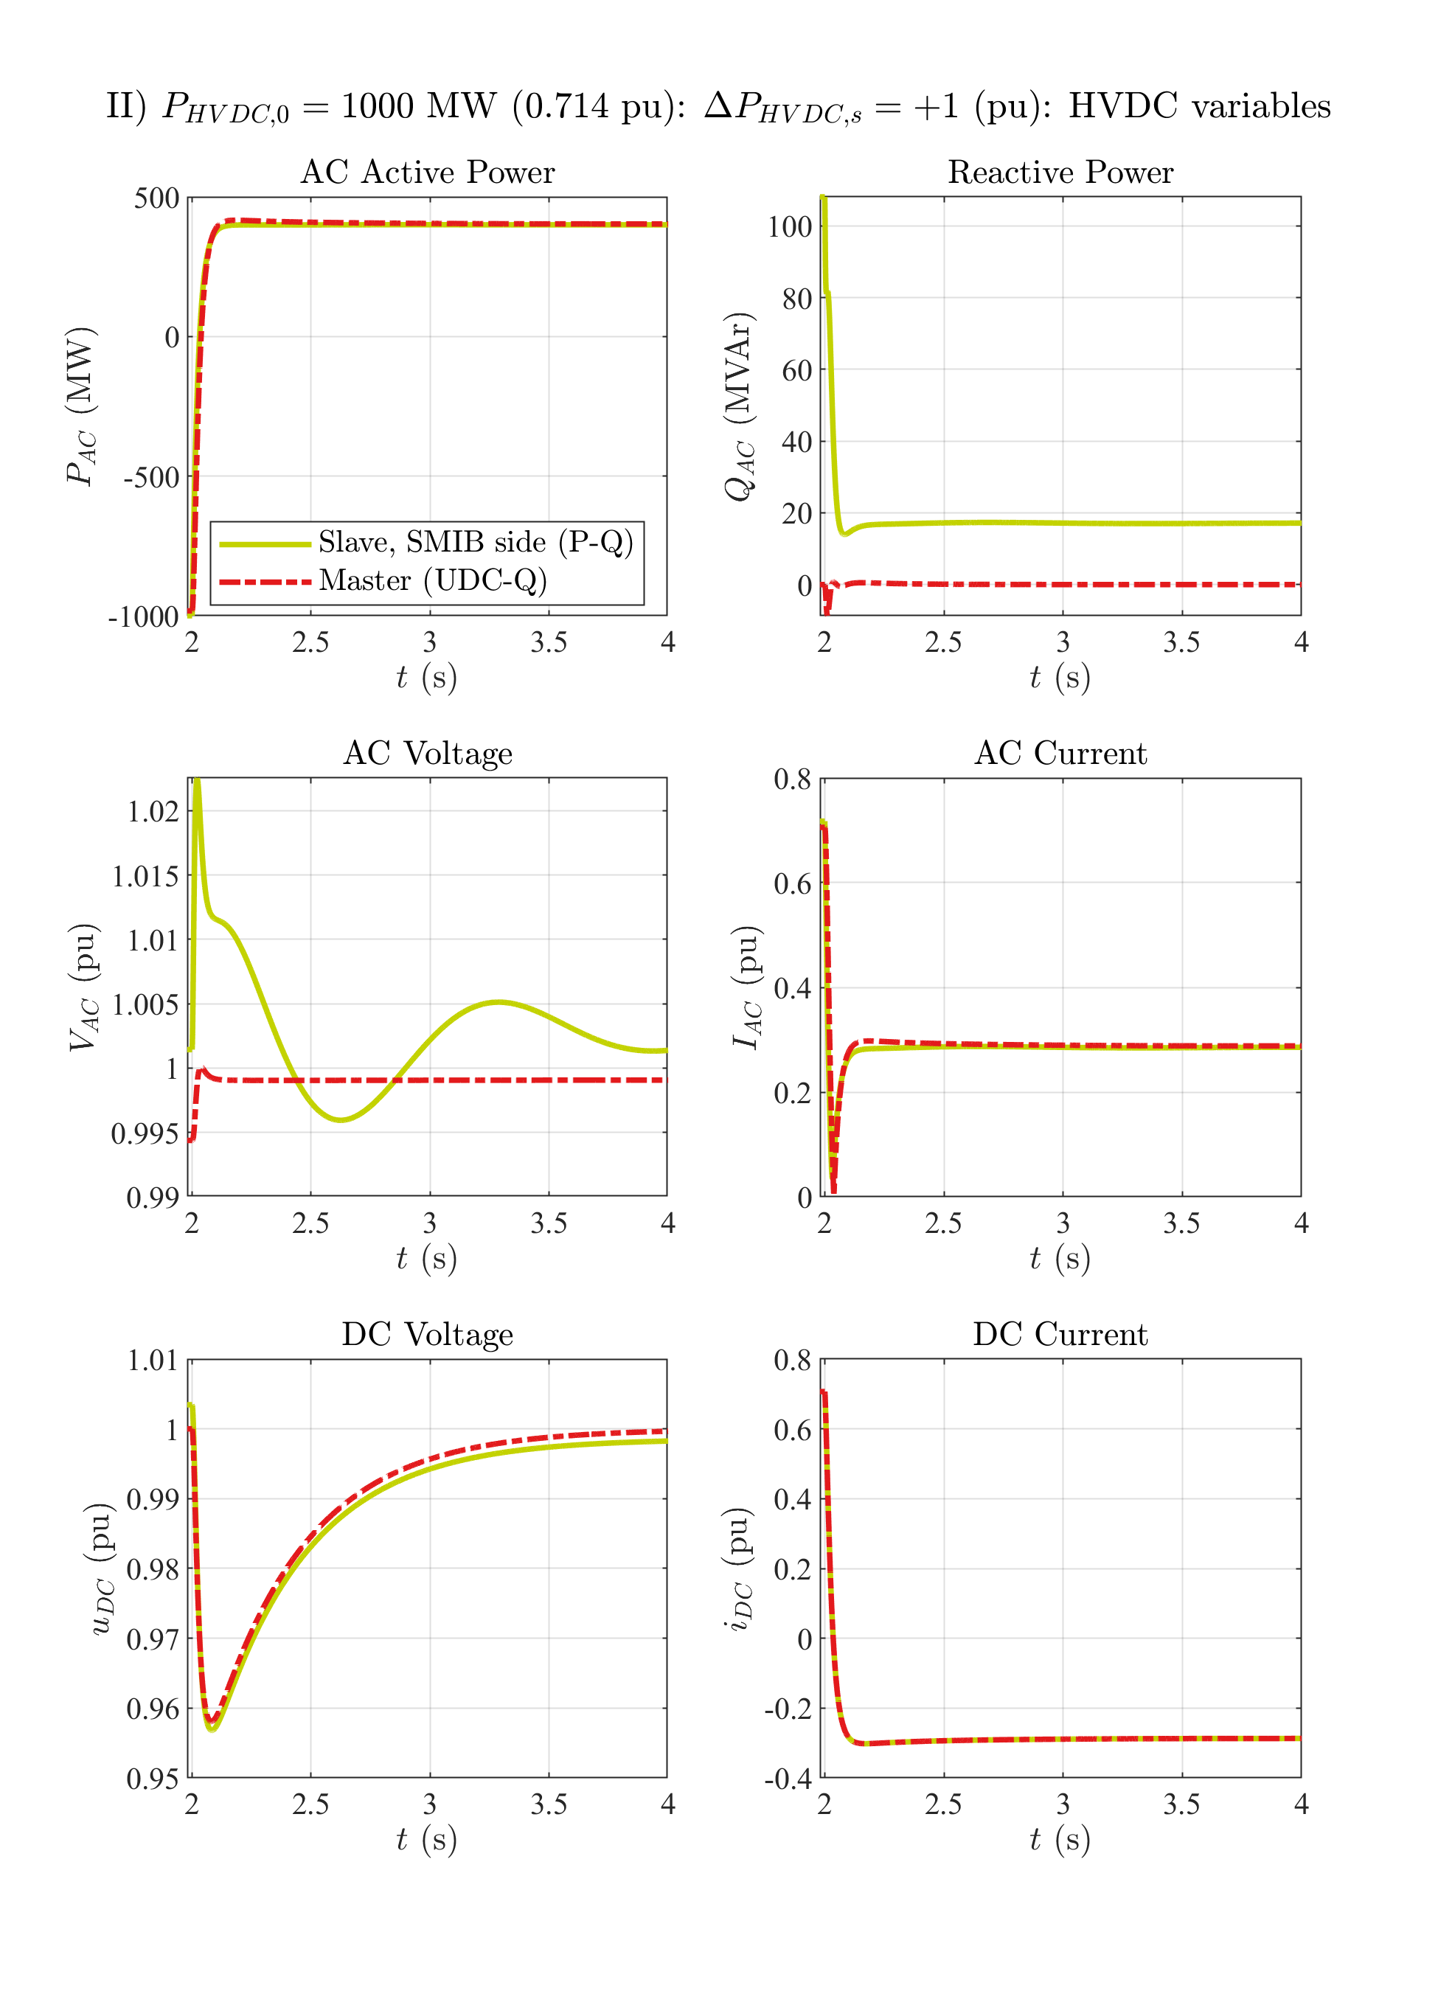

# 1GW HVDC power: P step up

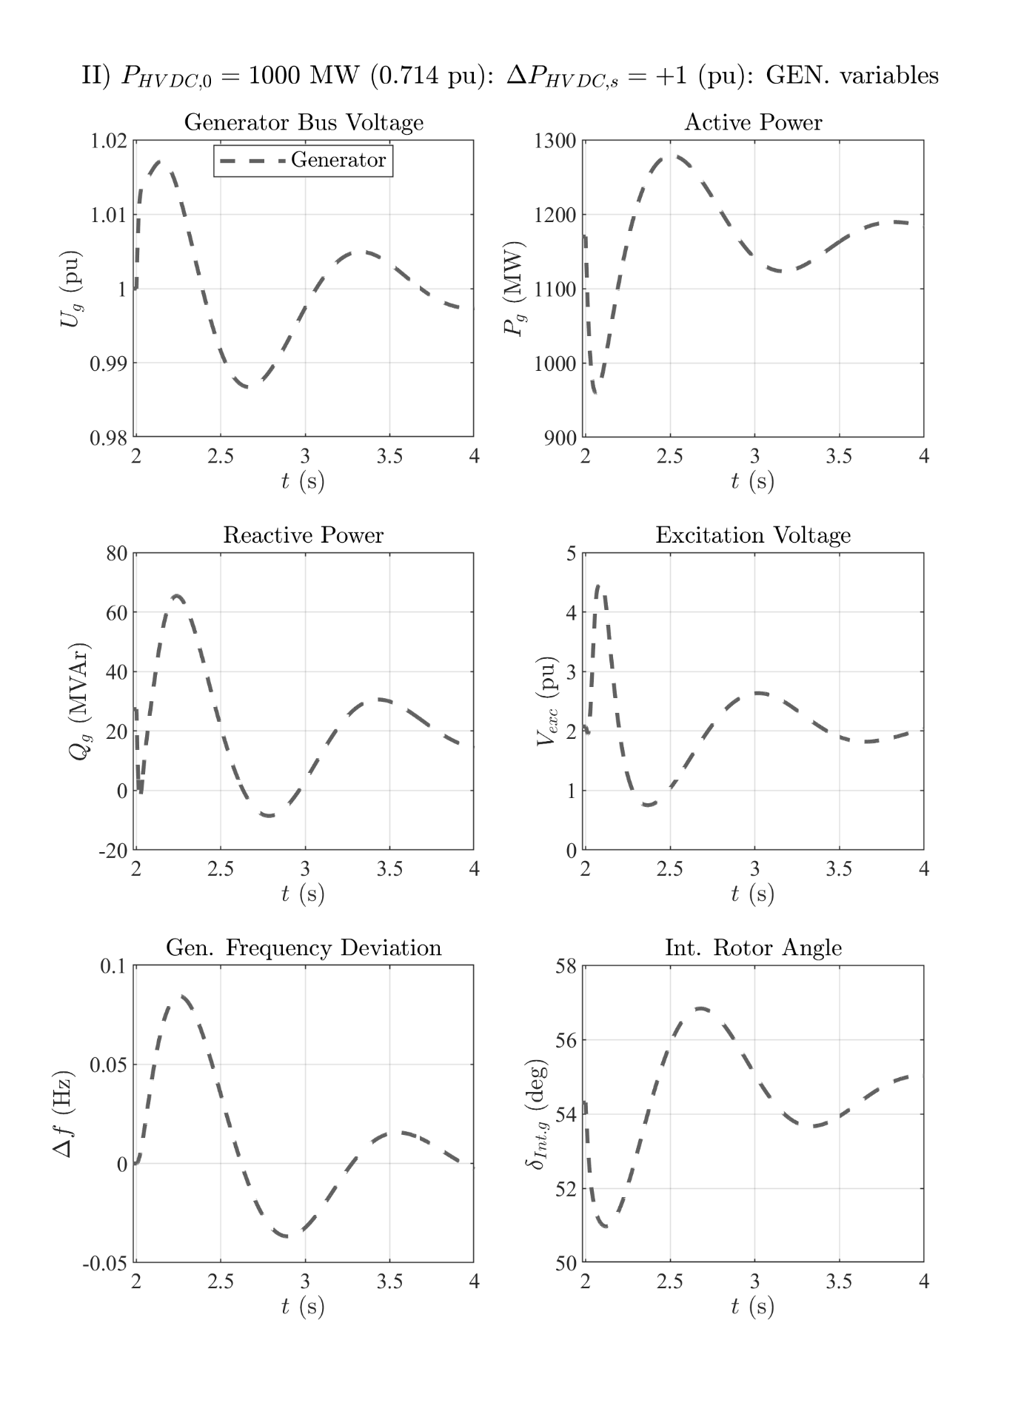

# 1GW HVDC power: Q step up

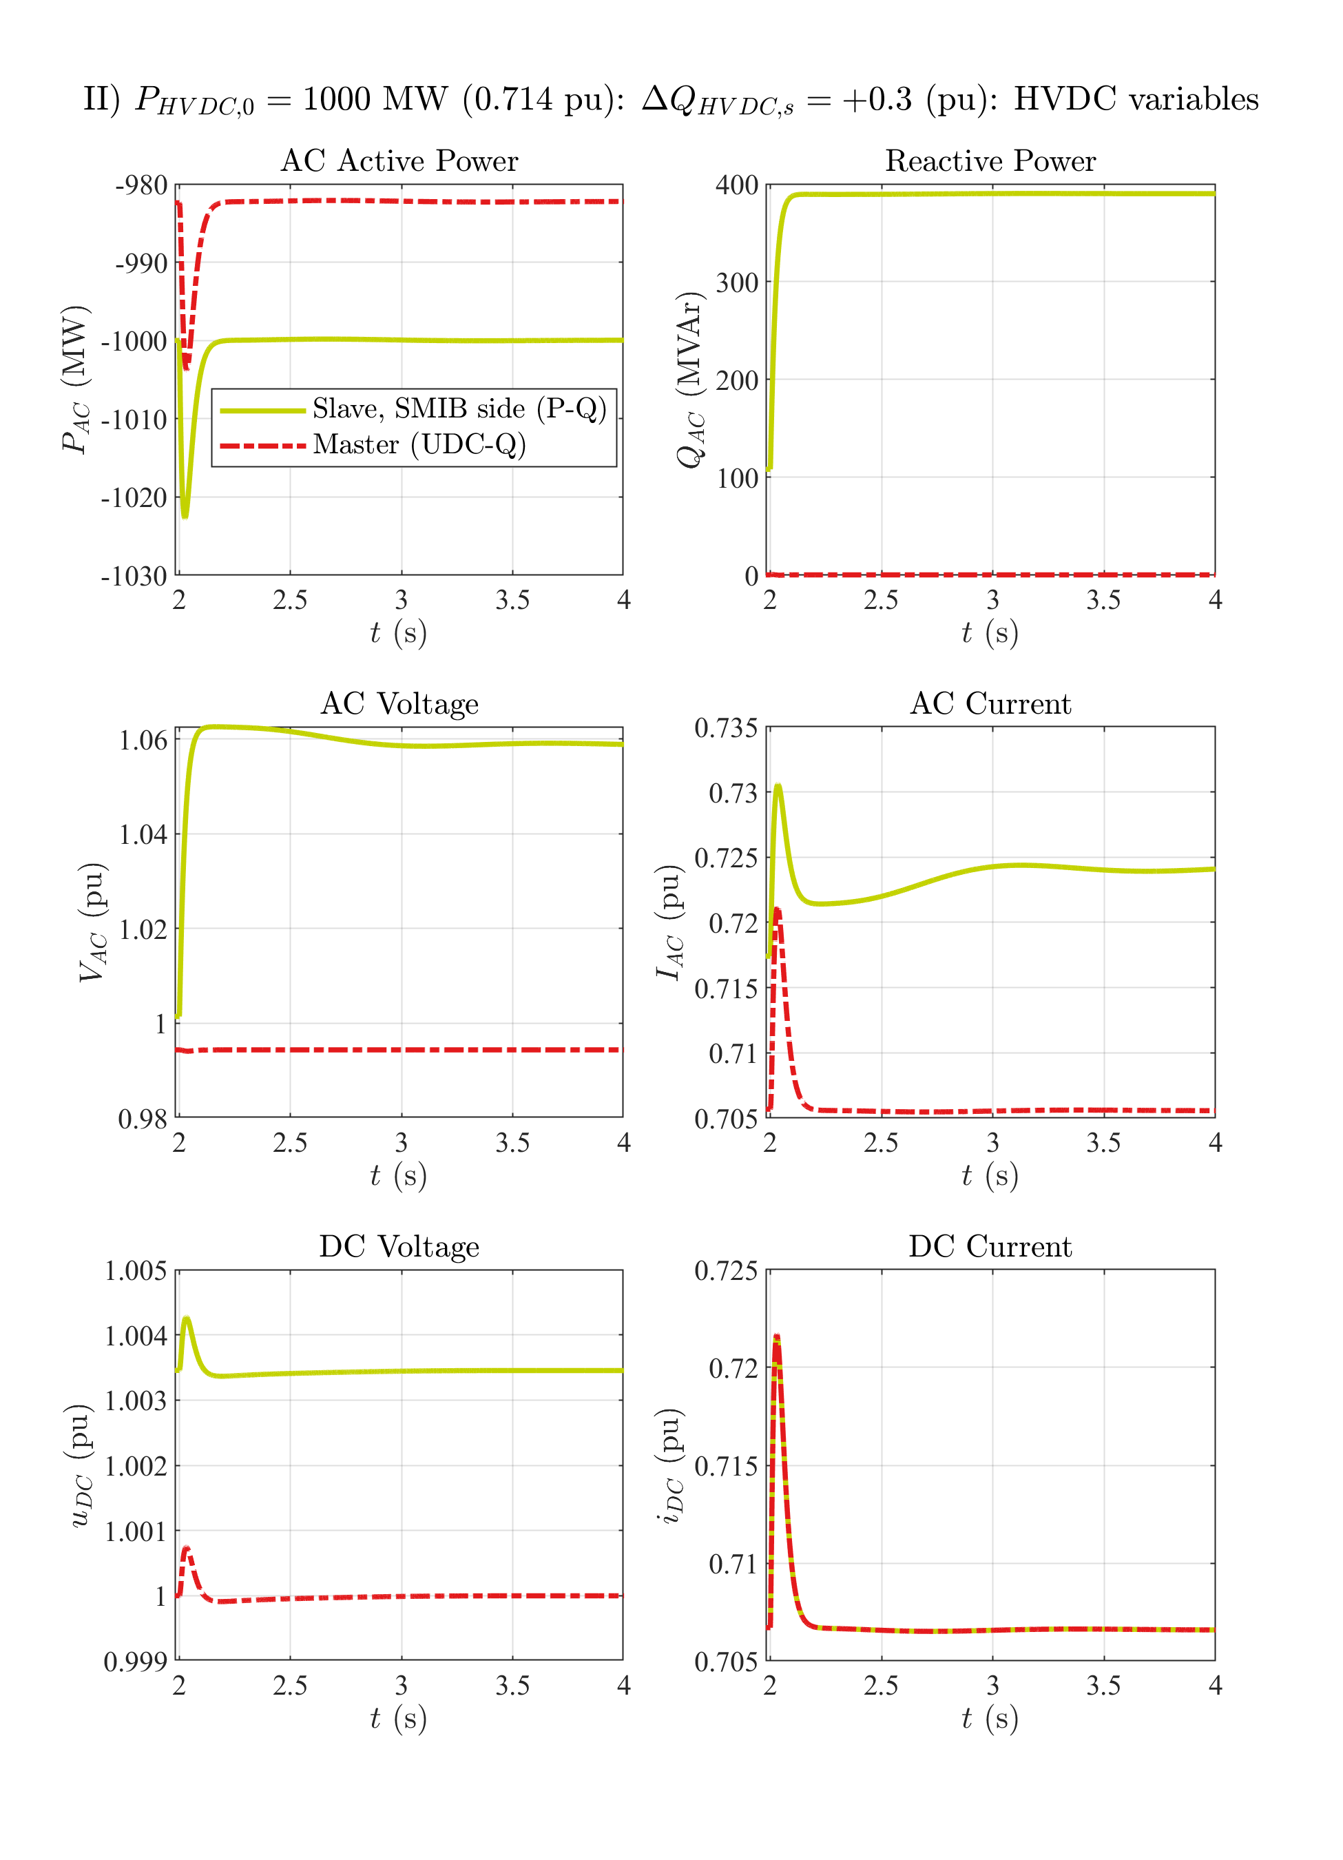

# 1GW HVDC power: Q step up

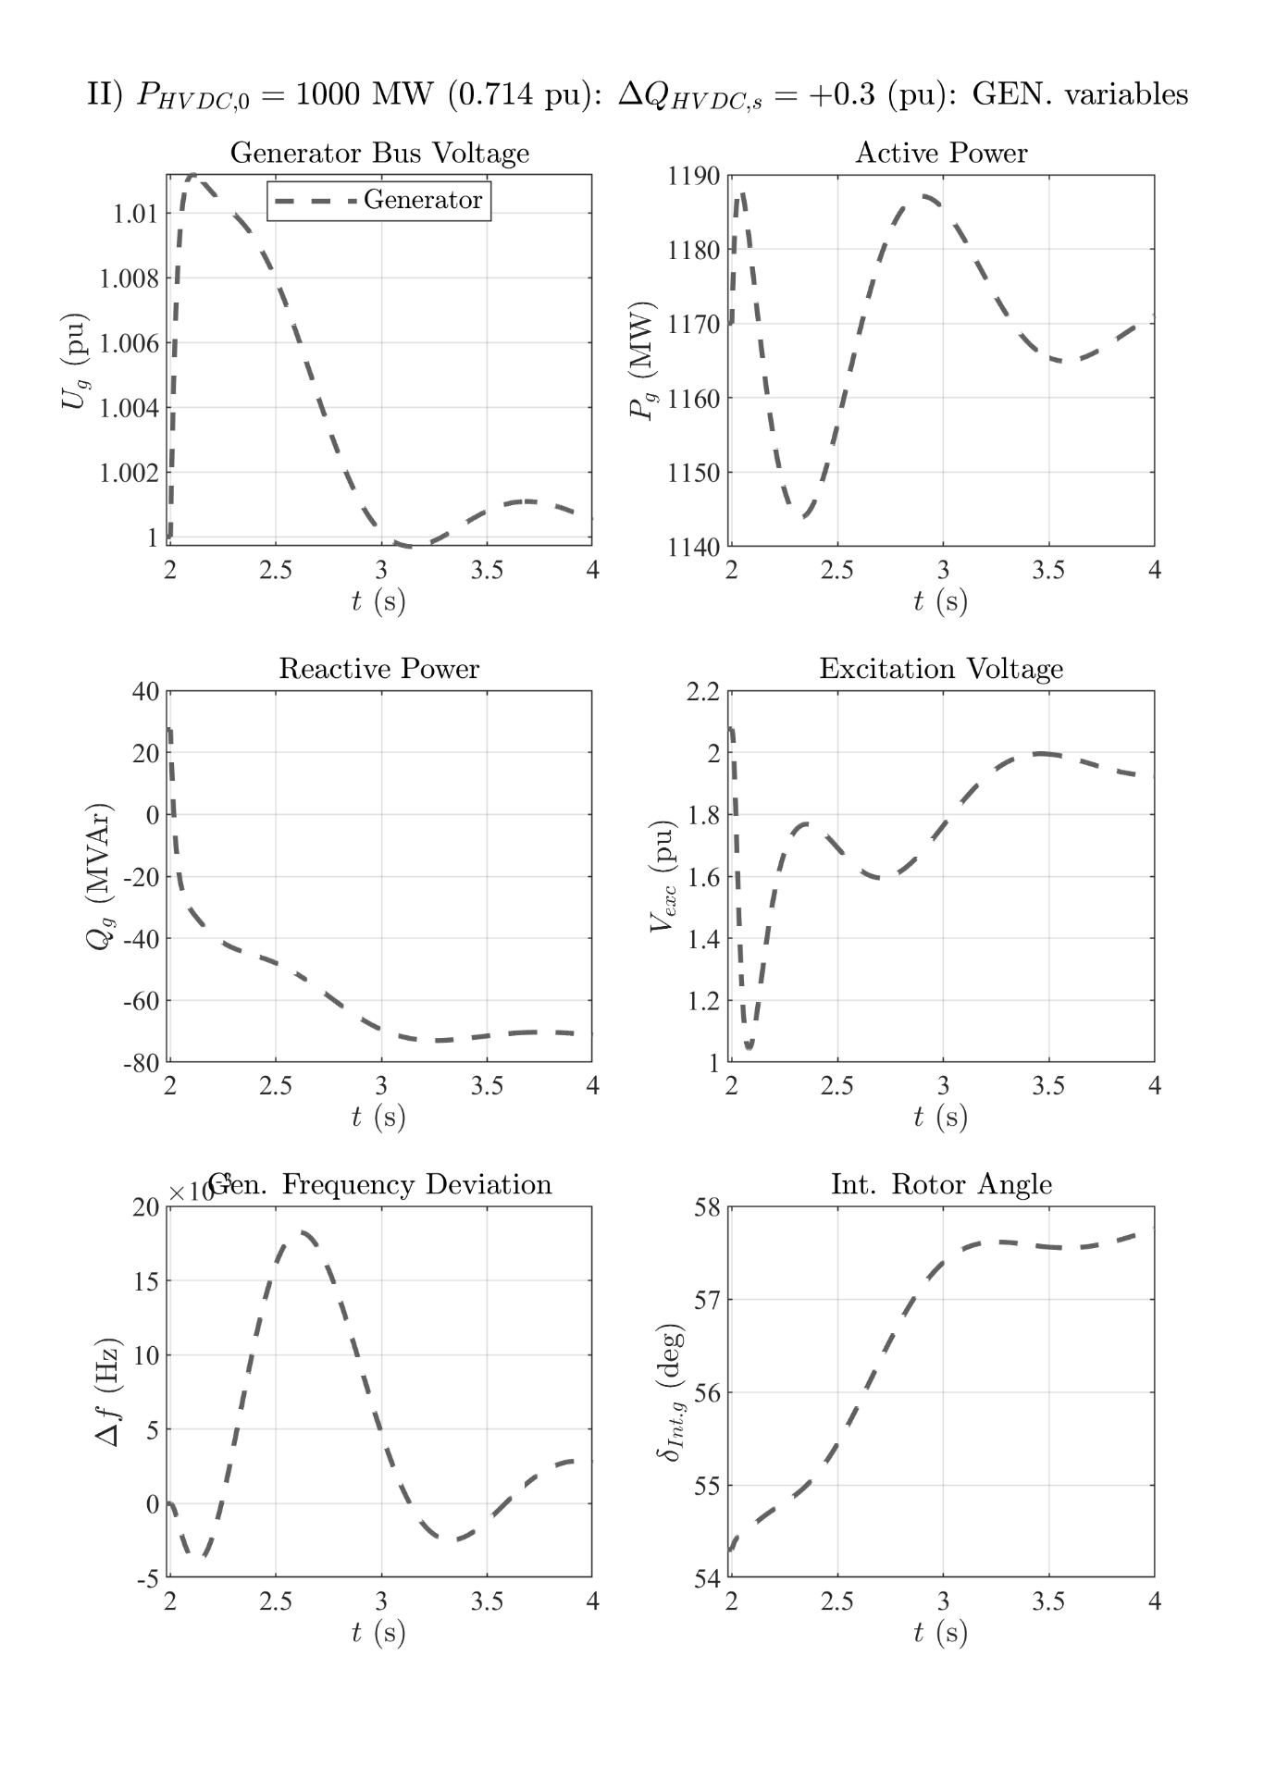

# 1GW HVDC power: Q step down

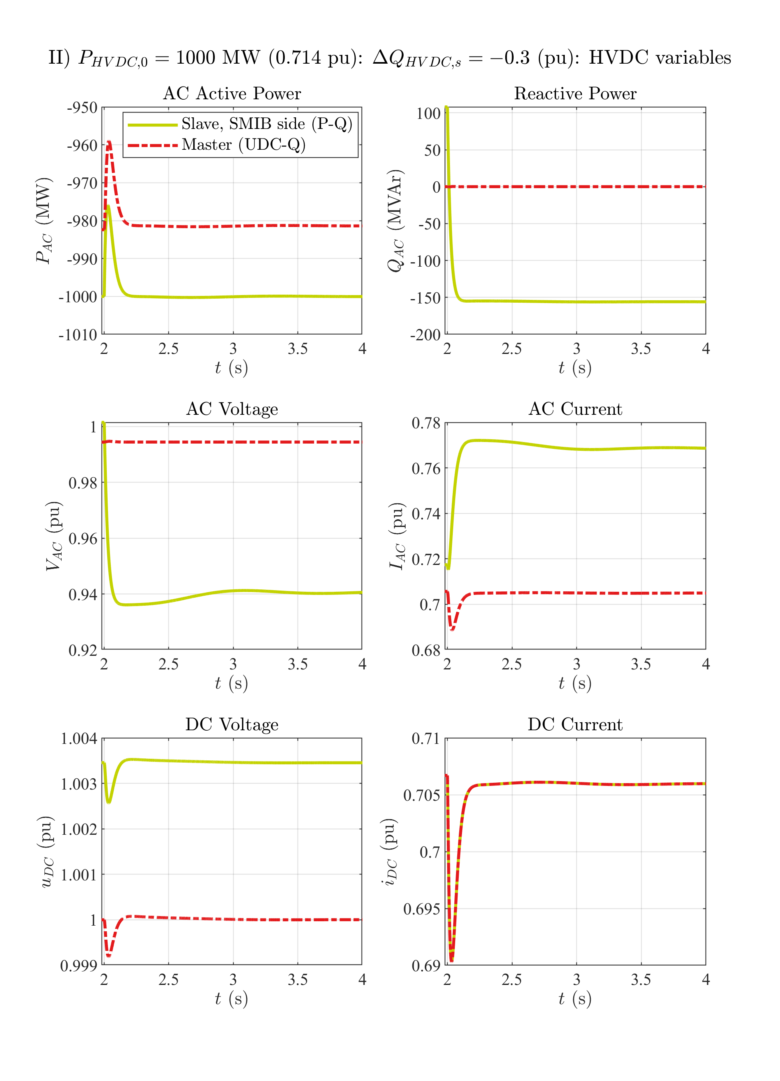

# 1GW HVDC power: Q step down

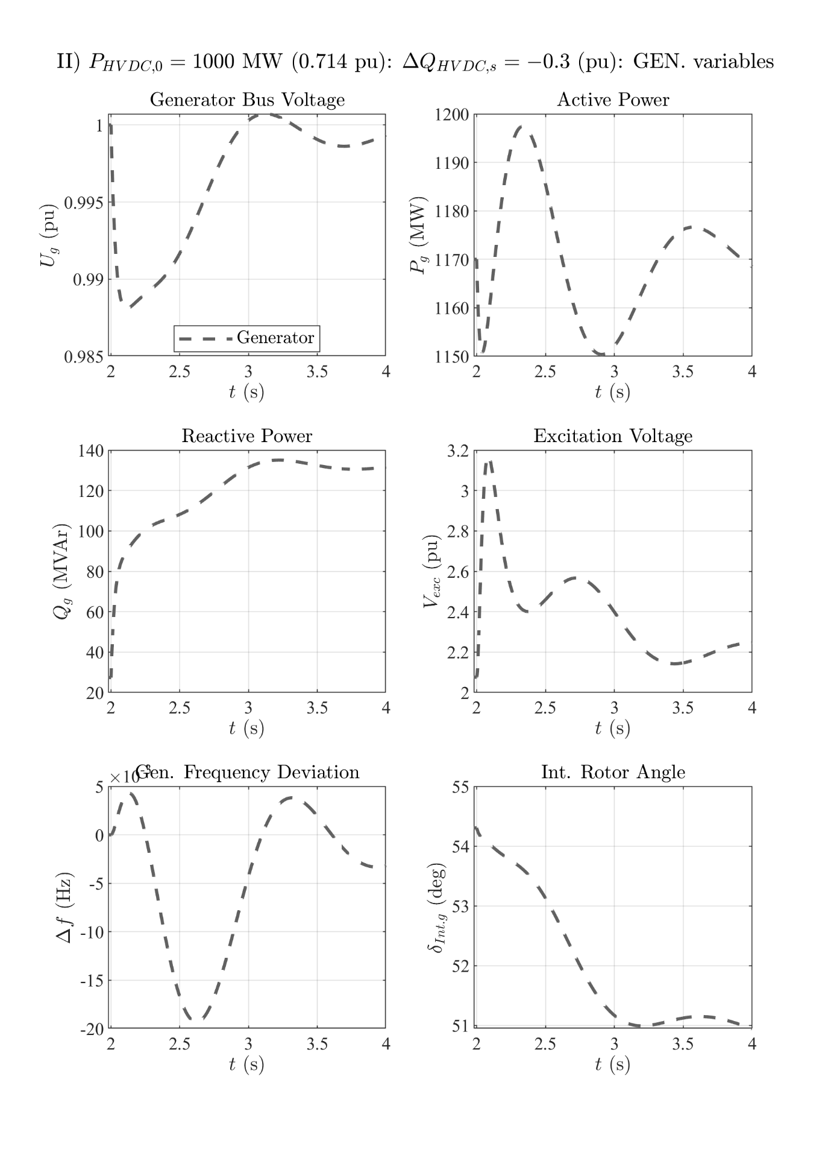

# 1GW HVDC power: 3pSC fault at the grid's PCC

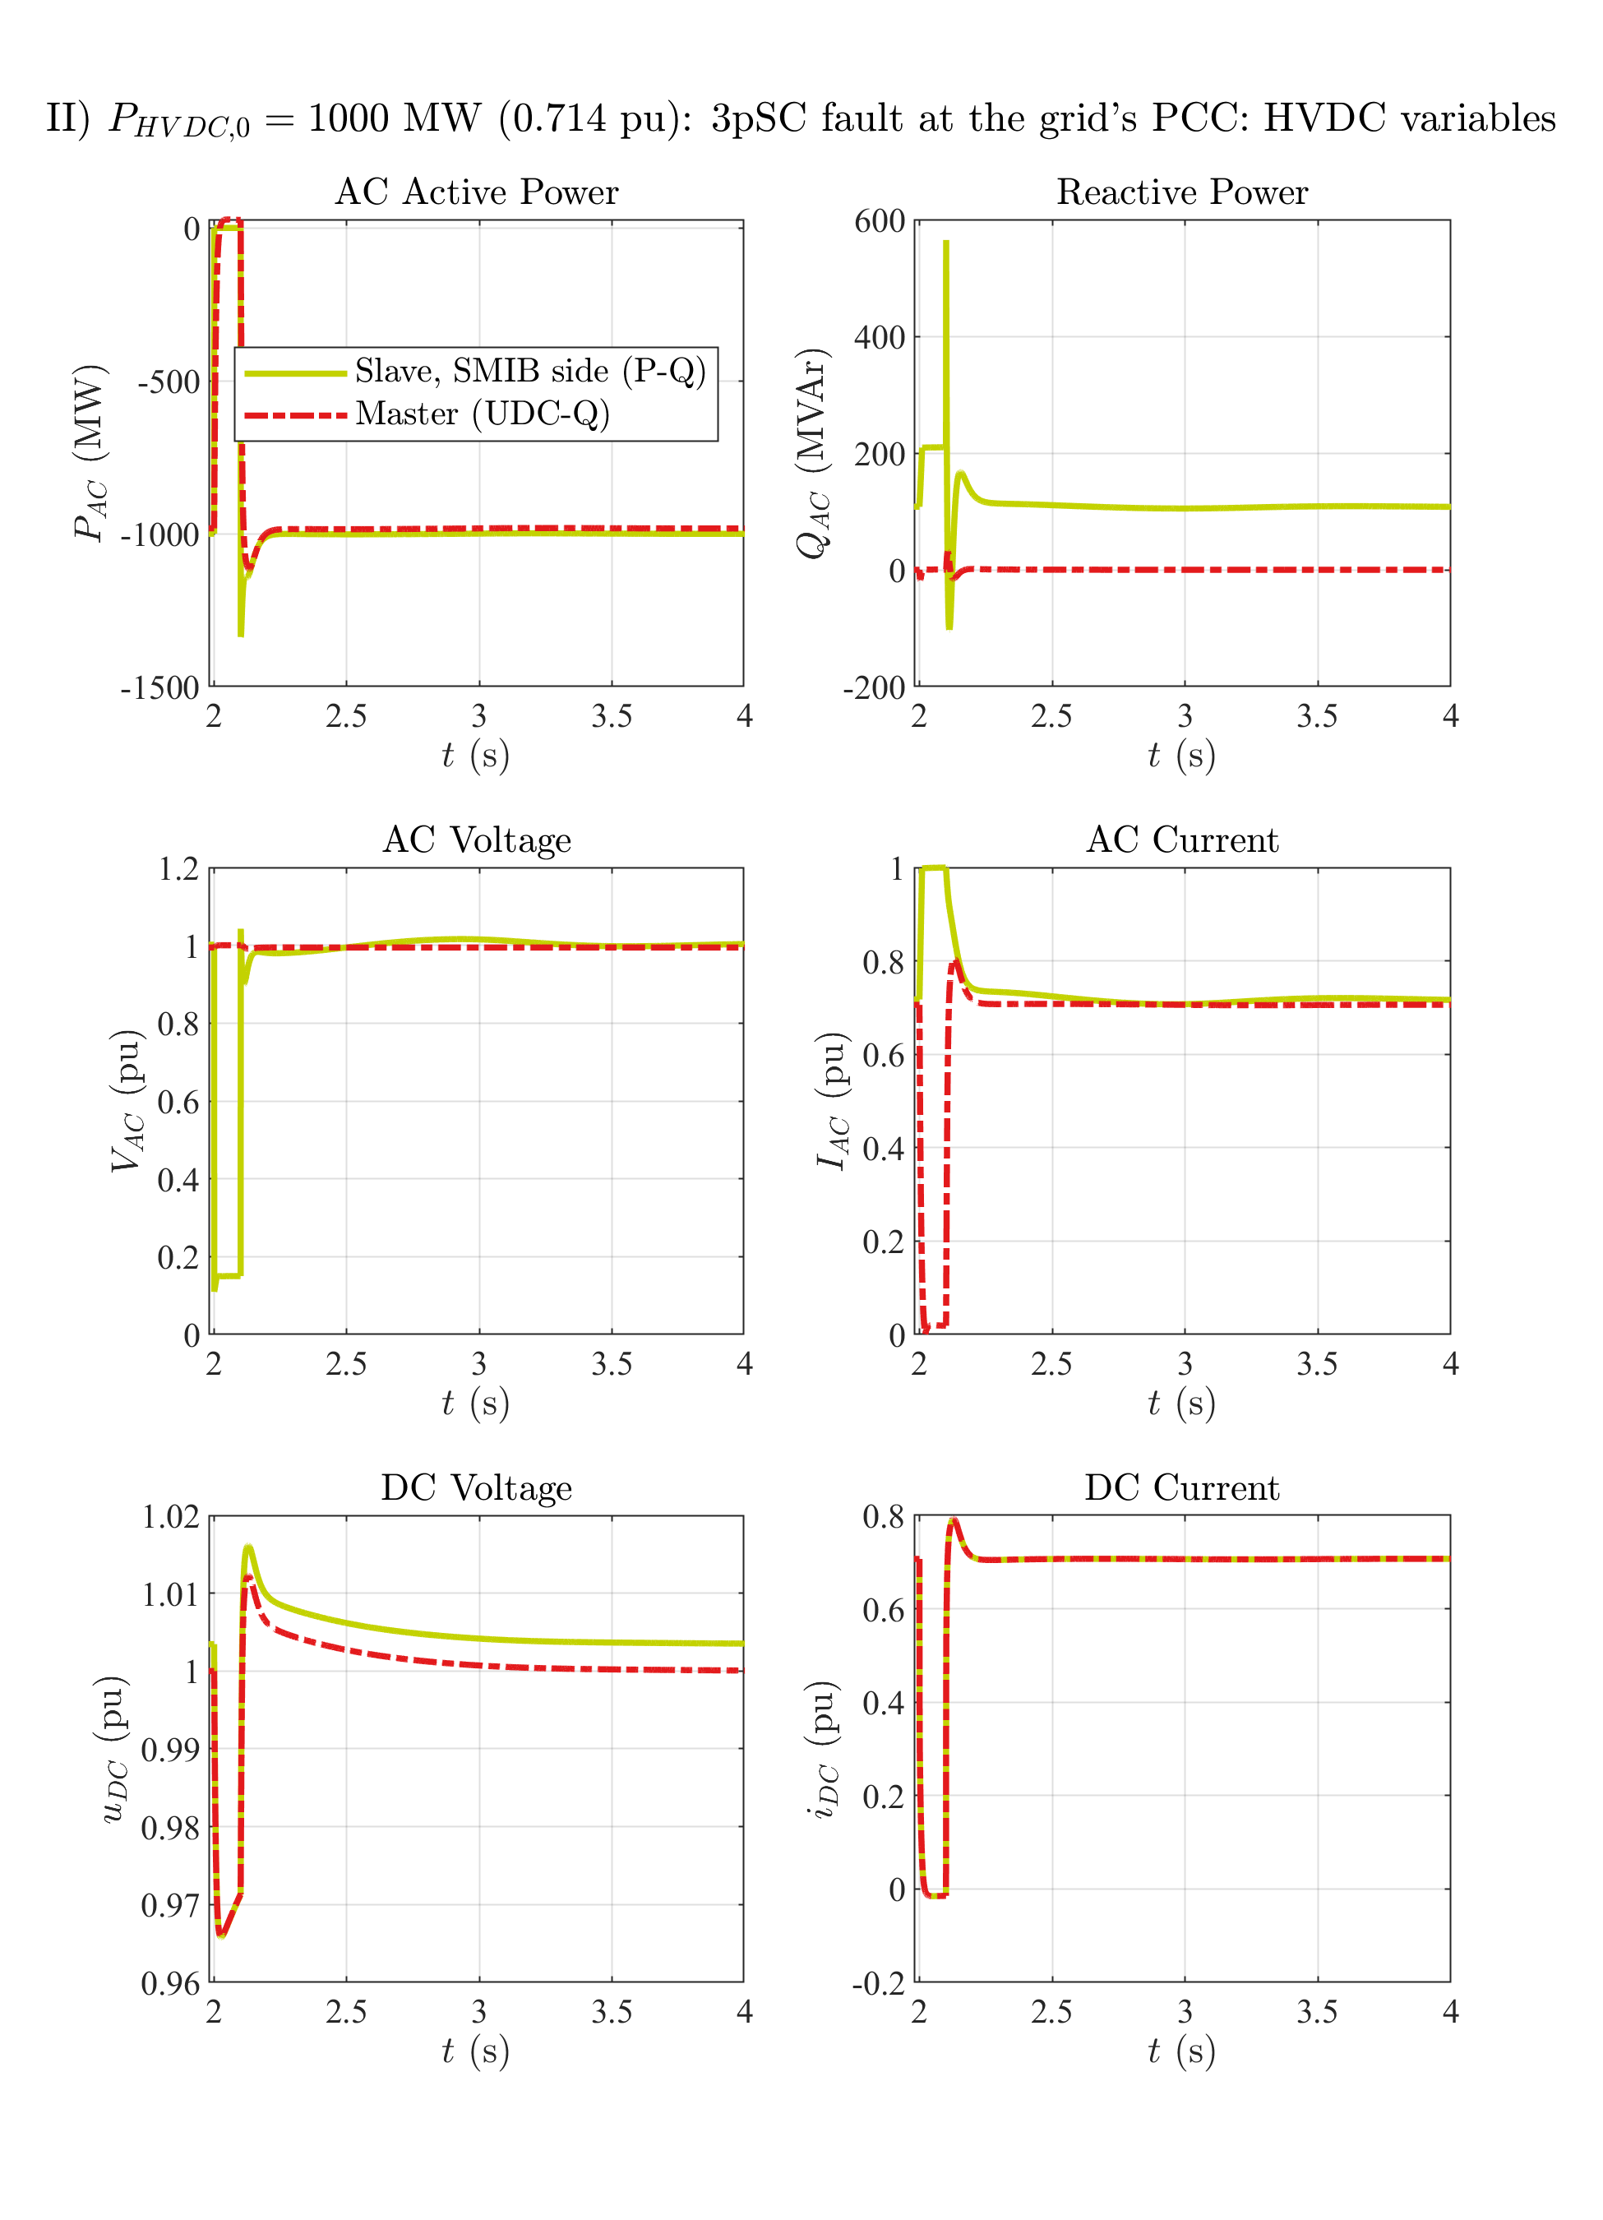

# 1GW HVDC power: 3pSC fault at the grid's PCC

